## Question Fifteen

### Instructions

Fill in all sections of the Test Report, start by completing the Project Details. Then list all the Test Cases and the associated Test Steps. Run the tests and record the results. Review the results and modify the code to ensure correct functionality of the application.

|  |  |  |  |  |  |  |  |  |
| --- | --- | --- | --- | --- | --- | --- | --- | --- |
| Test Report One | | | | | | | | |
| Project Details | | | | | | | | |
| Date | | 13-10-2021 | | | | | | |
| Team Name | | C Blunt | | | | | | |
| Team Members | | Bruce Fisher | | | Machyl Eberle (absent) | | | |
| Test Type | | **Functional Test of all the 4 Mathematical Methods.**  **Reduced the Array “**NeutrinoInteractions” **to a size of 10 for testing.**  **L**ine 30 - static int ArraySize = 10; | | | | | | |
| Test Case # | Test Case Name | | Test Steps | Test Data | | Expected Results | Evidence  (ref to Screen Capture) | Pass / Fail |
| 1 | Mid- Extreme | | 1. Left click on Button “AutoFill Data” 2. Left click on Button “Mid-Extreme” | 83, 66, 31, 29, 58, 95, 48, 12, 10, 61 | | 52.5 | Test Case 1 | Pass |
| 2 | Mid- Extreme | | 1. Left click on Button “AutoFill Data” 2. Left click on Button “Mid-Extreme” | 25, 57, 21, 46, 82, 55, 40, 45, 88, 33 | | 54.5 | Test Case 2 | Pass |
| 3 | Mid-Extreme | | 1. Left click on Button “AutoFill Data” 2. Left click on Button “Mid-Extreme” | 61, 54, 95, 16, 30, 36, 49, 15, 42, 42 | | 55 | Test Case 3 | Pass |
| 4 | Mid-Extreme | | 1. Left click on Button “AutoFill Data” 2. Left click on Button “Mid-Extreme” | 50, 43, 38, 13, 71, 77, 21, 62, 71, 10 | | 43.5 | Test Case 4 | Pass |
| 5 | Mode | | 1. Left click on Button “AutoFill Data” 2. Left click on Button “Mode” | 47, 17, 17, 67, 44, 32, 99, 92, 53, 53 | | 17 – 2  53 – 2 | Test Case 5 | Pass |
| 6 | Mode | | 1. Left click on Button “AutoFill Data” 2. Left click on Button “Mode” | 17, 72, 13, 57, 55, 88, 21, 41, 18, 90 | | All Mode Frequencies 1 | Test Case 6 | Pass |
| 7 | Mode | | 1. Left click on Button “AutoFill Data” 2. Left click on Button “Mode” | 27, 89, 10, 19, 27, 22, 22, 22, 14, 54 | | 22 – 3 | Test Case 7 | Pass |
| 8 | Mode | | 1. Left click on Button “AutoFill Data” 2. Left click on Button “Mode” | 45, 86, 12, 30, 30, 56, 53, 49, 45, 49 | | 30 – 2  45 – 2  49 – 2 | Test Case 8 | Pass |
| 9 | Average | | 1. Left click on Button “AutoFill Data” 2. Left click on Button “Average” | 13, 86, 52, 10, 86, 18, 65, 16, 84, 14 | | 44.4 | Test Case 9 | Pass |
| 10 | Average | | 1. Left click on Button “AutoFill Data” 2. Left click on Button “Average” | 26, 92, 58, 25, 36, 32, 70, 40, 69, 90 | | 53.8 | Test Case 10 | Pass |
| 11 | Average | | 1. Left click on Button “AutoFill Data” 2. Left click on Button “Average” | 44, 48, 99, 68, 43, 97, 93, 71, 98, 72 | | 73.3 | Test Case 11 | Pass |
| 12 | Average | | 1. Left click on Button “AutoFill Data” 2. Left click on Button “Average” | 42, 10, 56, 52, 89, 30, 32, 92, 48, 49 | | 53 | Test Case 12 | Pass |
| 13 | Range | | 1. Left click on Button “AutoFill Data” 2. Left click on Button “Range” | 50, 85, 14, 44, 75, 49, 22, 45, 15, 54 | | 71 | Test Case 13 | Pass |
| 14 | Range | | 1. Left click on Button “AutoFill Data” 2. Left click on Button “Range” | 40, 81, 77, 83, 82, 13, 40, 65, 63, 33 | | 70 | Test Case 14 | Pass |
| 15 | Range | | 1. Left click on Button “AutoFill Data” 2. Left click on Button “Range” | 57, 89, 50, 99, 54, 92, 87, 55, 31, 12 | | 87 | Test Case 15 | Pass |
| 16 | Range | | 1. Left click on Button “AutoFill Data” 2. Left click on Button “Range” | 43, 74, 41, 44, 95, 56, 22, 79, 49, 20 | | 75 | Test Case 16 | Pass |
| 17 | NO data in the list Test…  Mid- Extreme + Average + Range  Same test for all as all call same function MathCalculations() | | 1. Left click on Button “Mid-Extreme” 2. Left click on Button “Average” 3. Left click on Button “Range” | Nothing | | Error message “Error: No data in the list” | Test Case 17 | Pass |
| 18 | NO data in the list Test…  Mode | | 1. Left click on Button “Mode” | Nothing | | Error message “Error: No data in the list” | Test Case 18 | Pass |

## Test Case 1

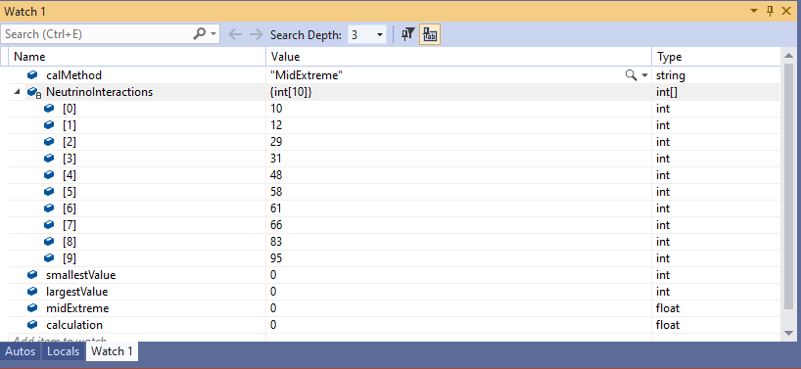

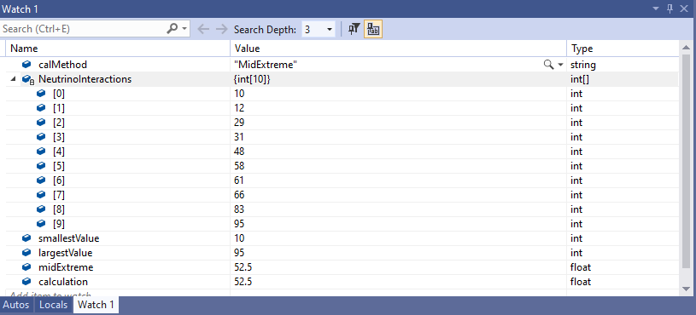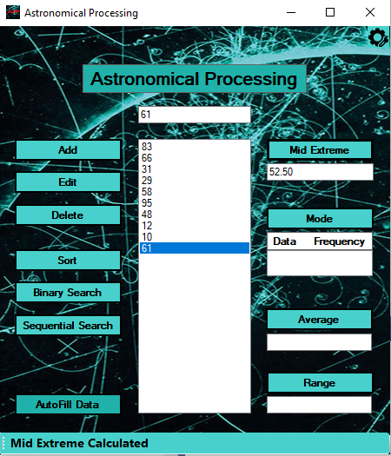

## Test Case 2

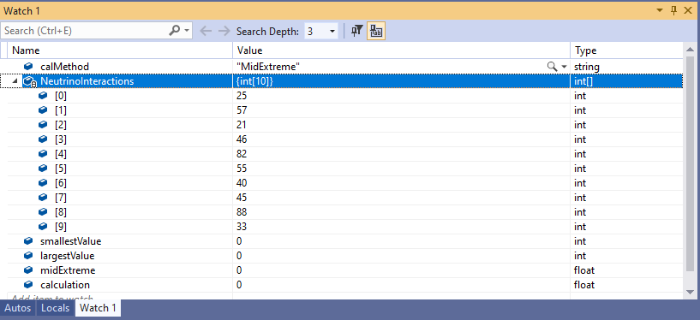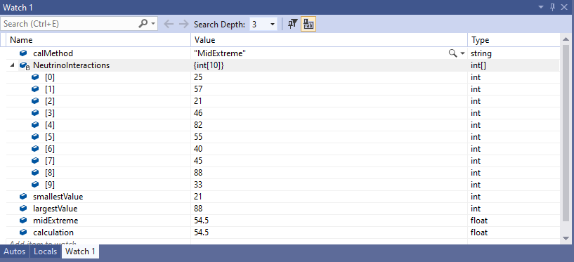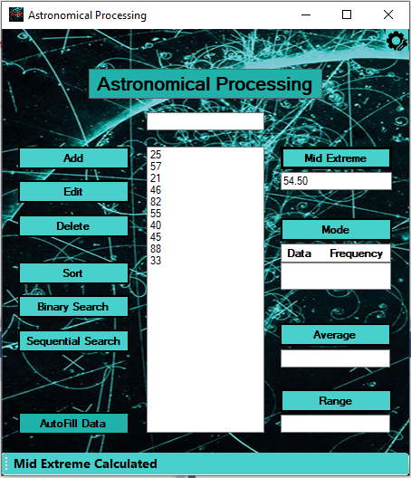

## Test Case 3

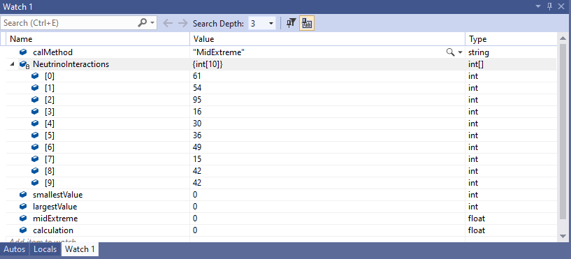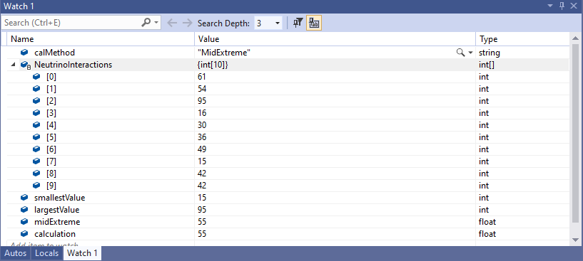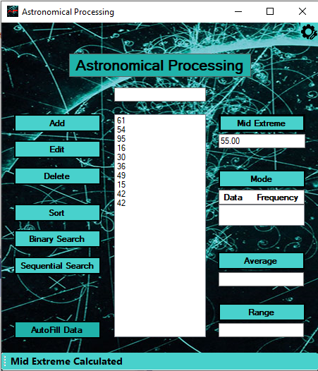

## Test Case 4

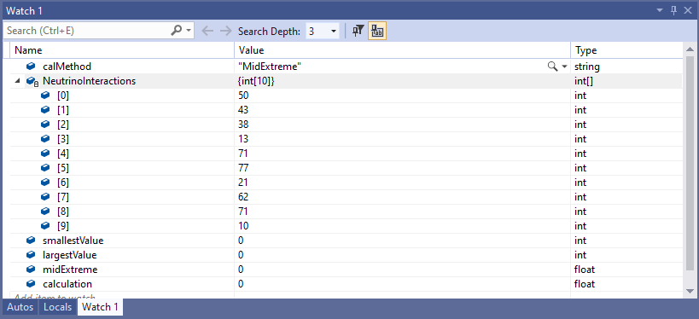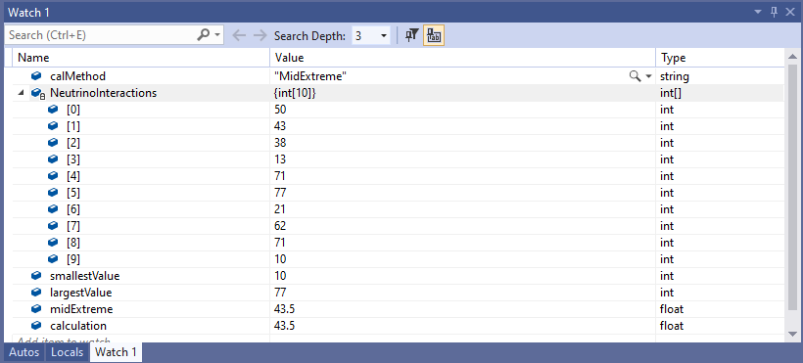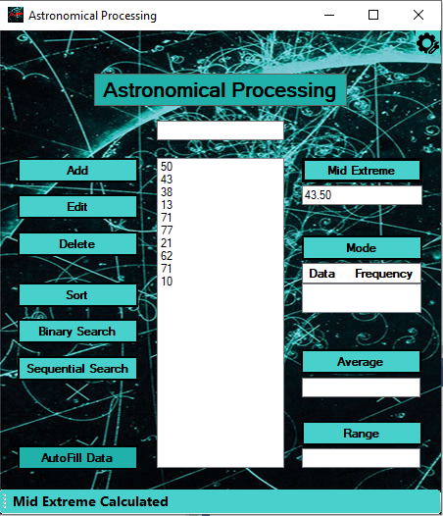

## Test Case 5

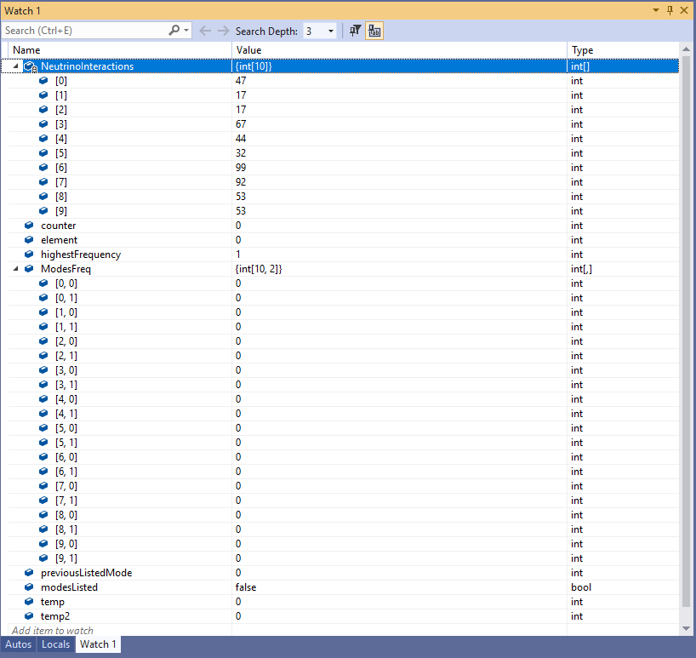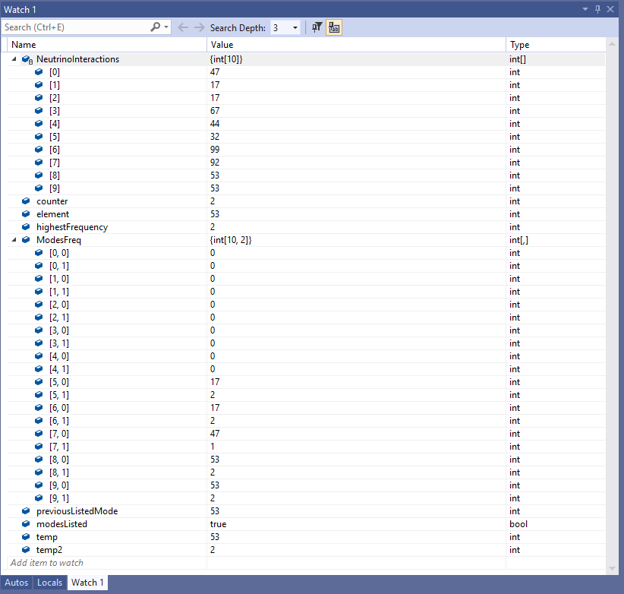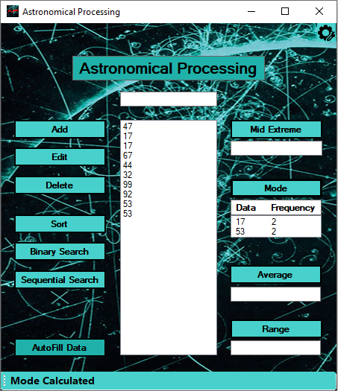

## Test Case 6

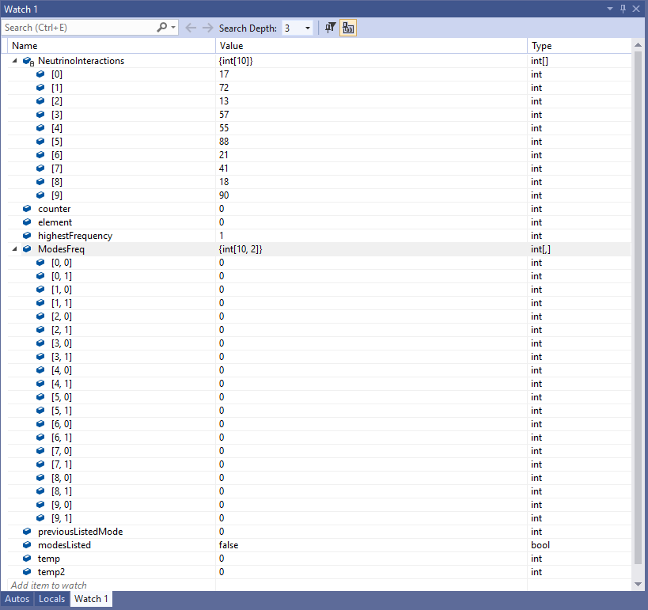

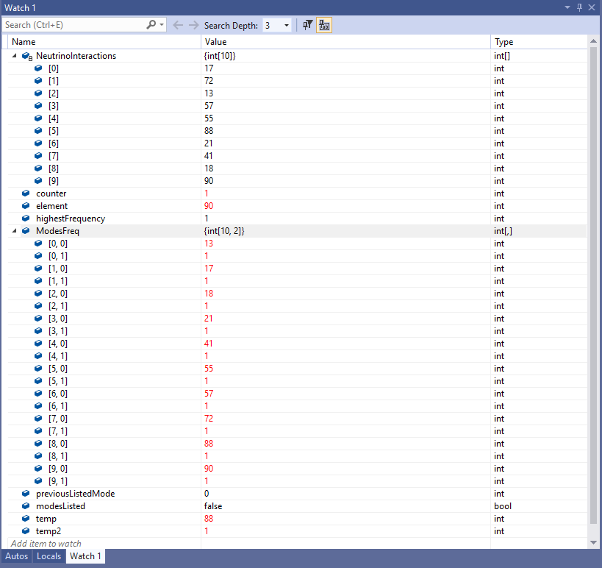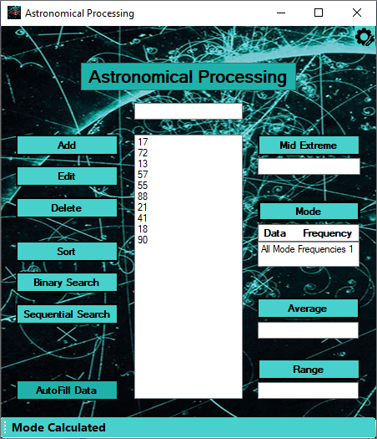

## Test Case 7

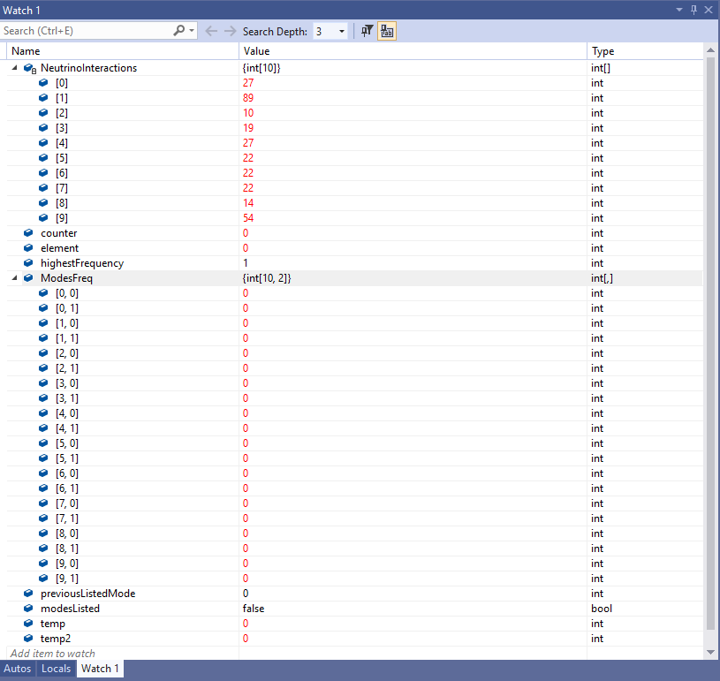

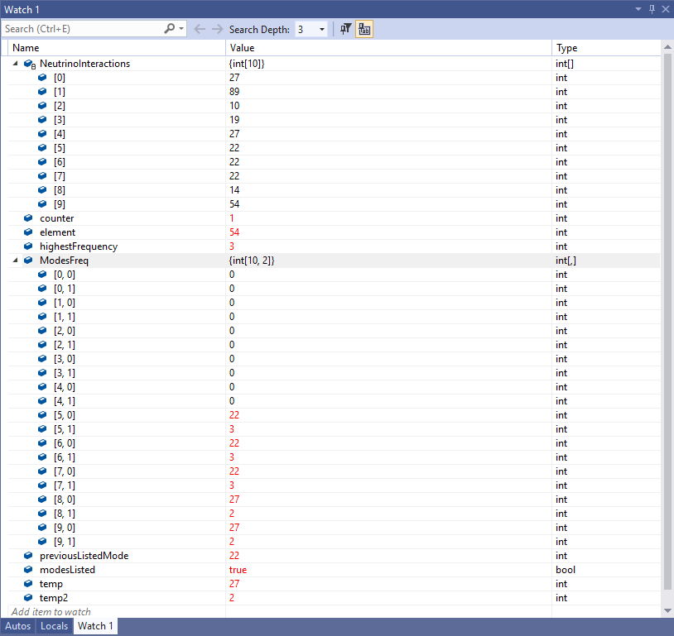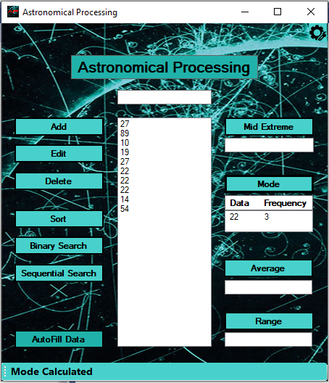

## Test Case 8

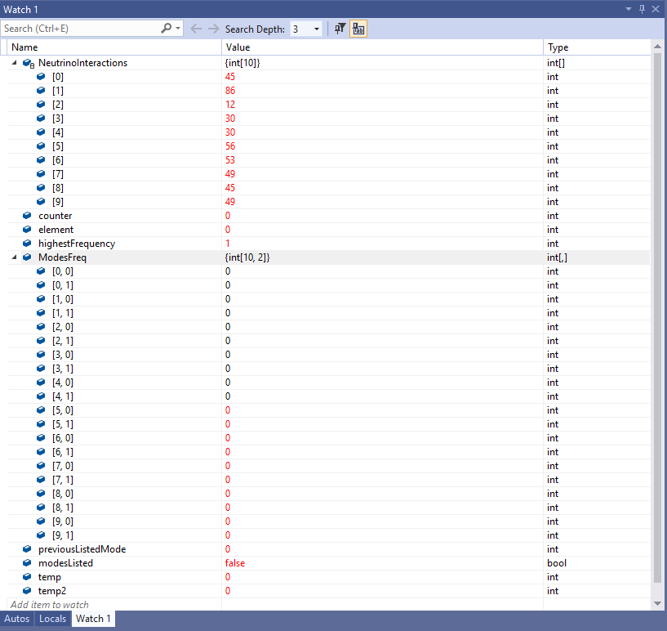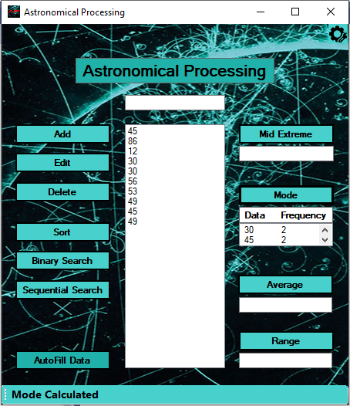

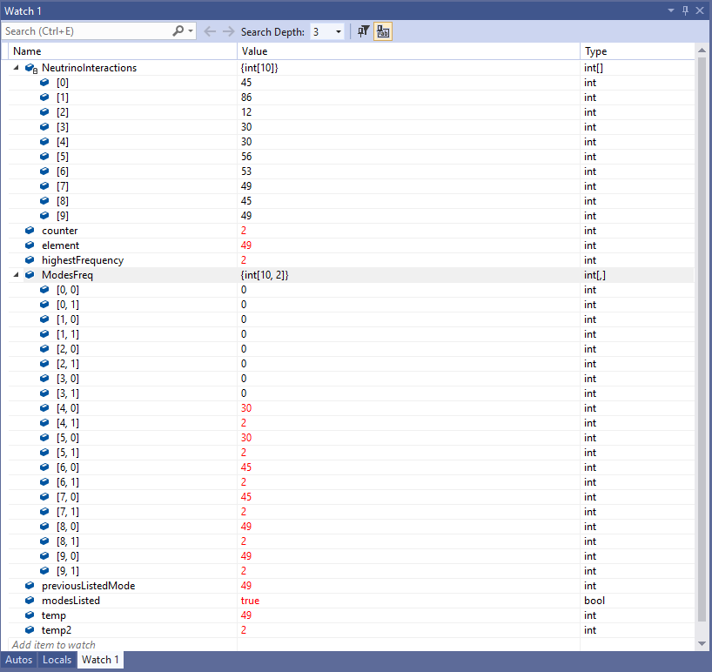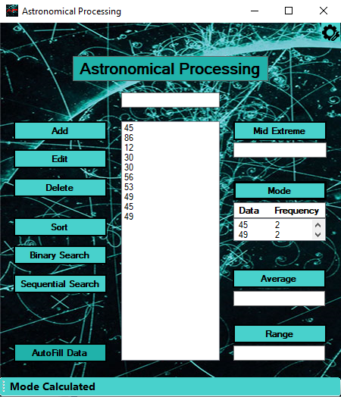

## Test Case 9

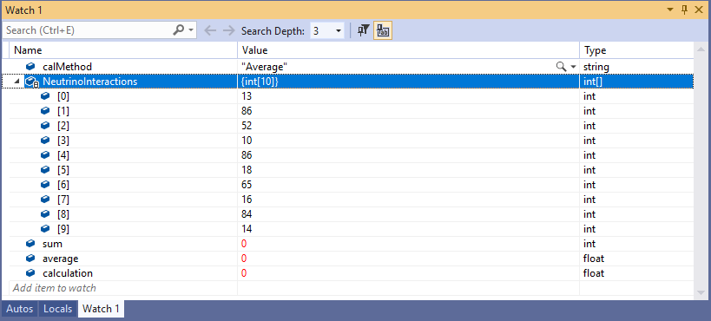

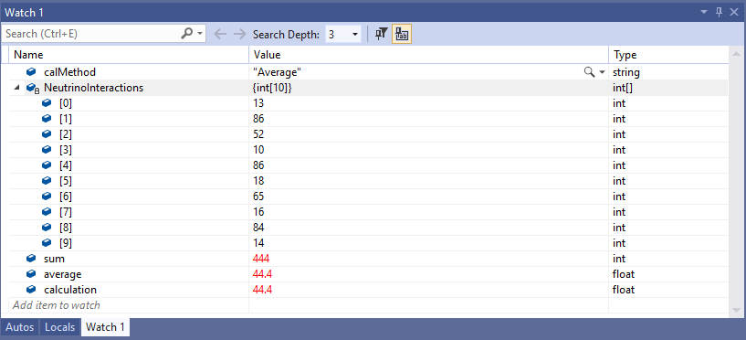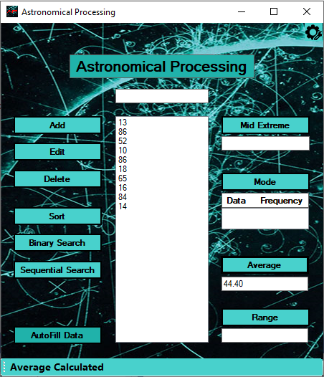

## Test Case 10

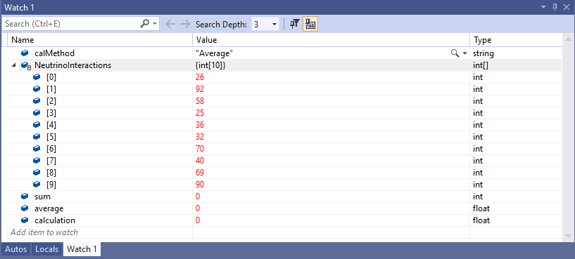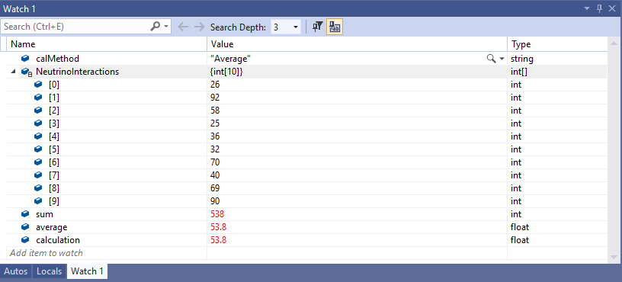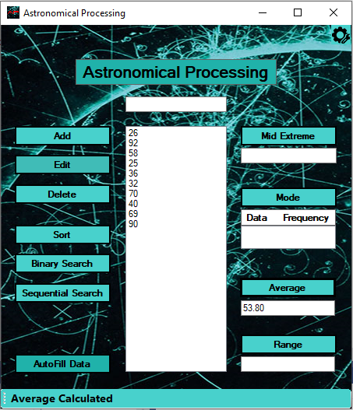

## Test Case 11

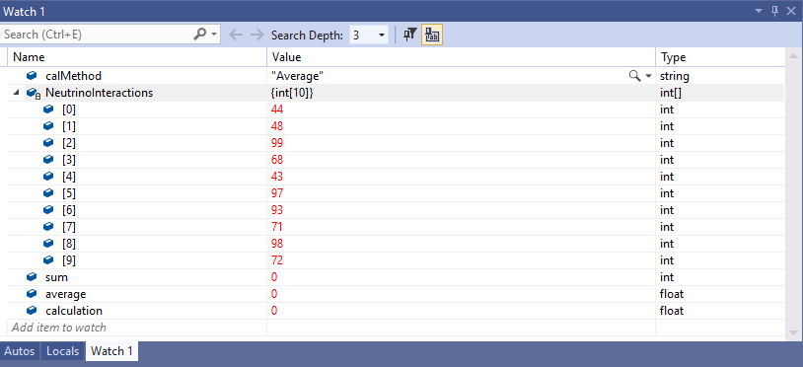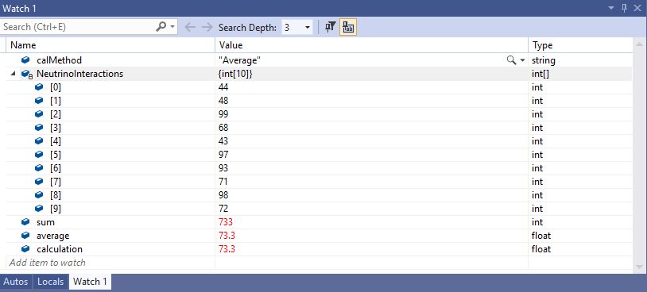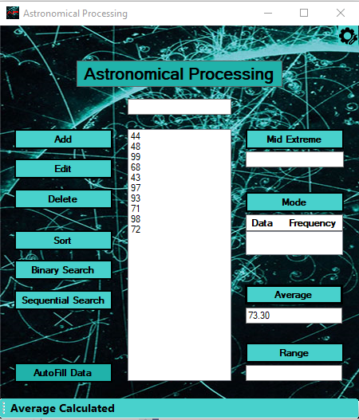

## Test Case 12

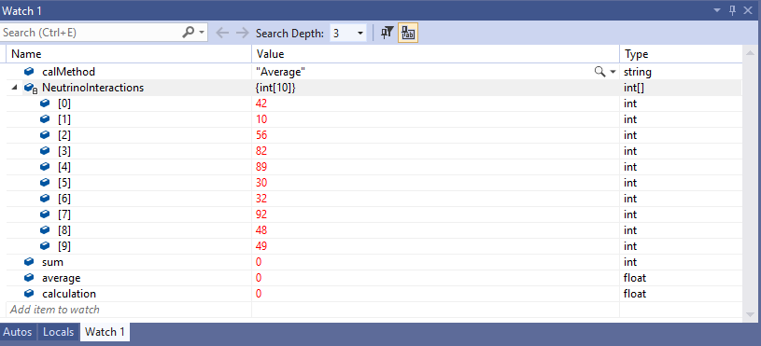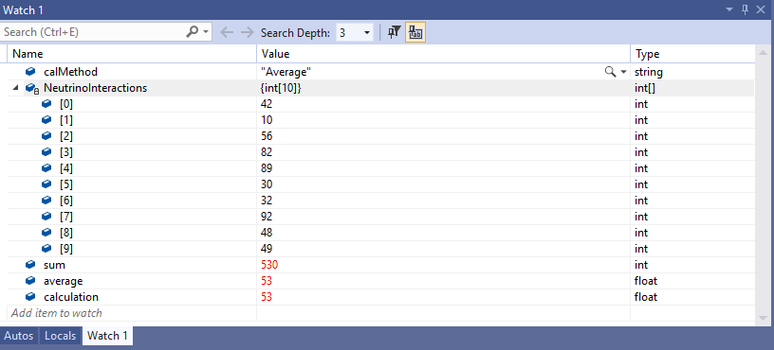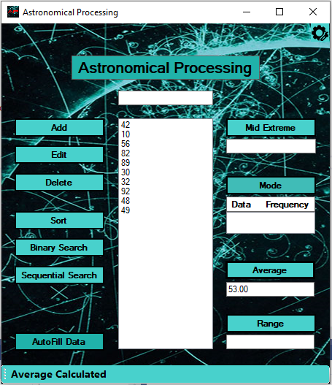

## Test Case 13

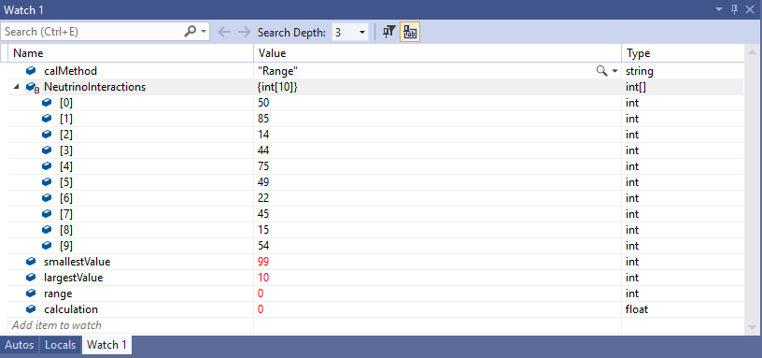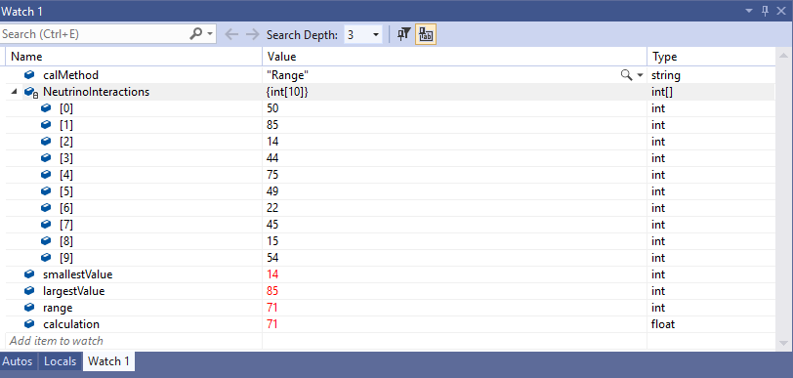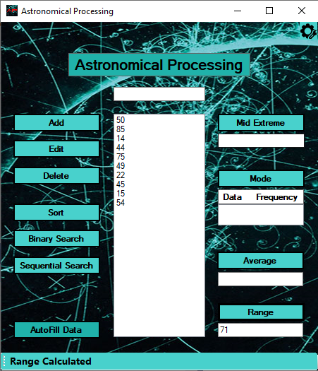

## Test Case 14

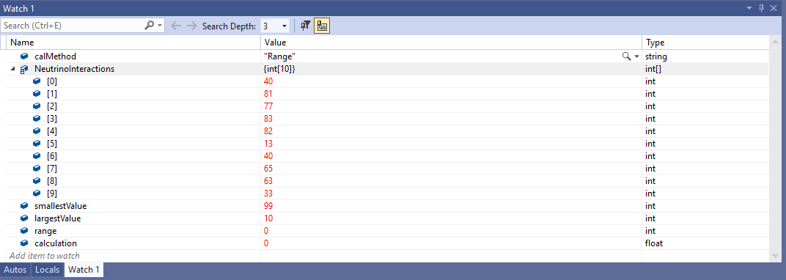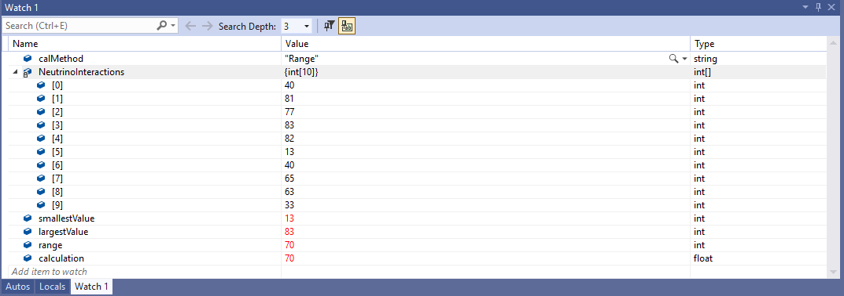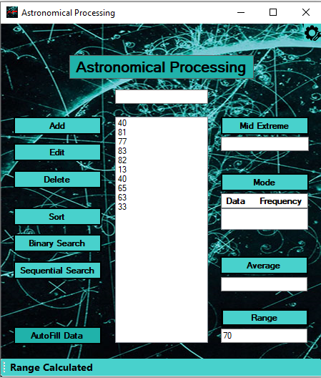

## Test Case 15

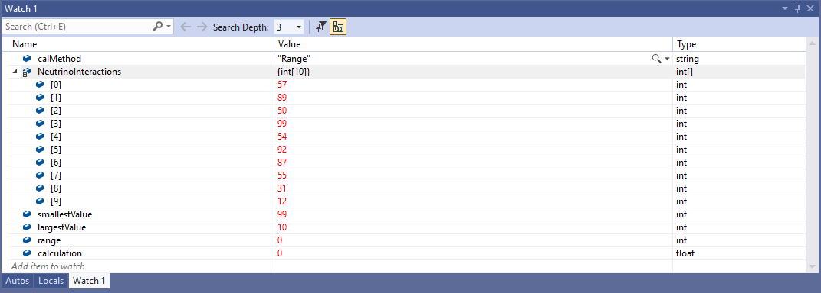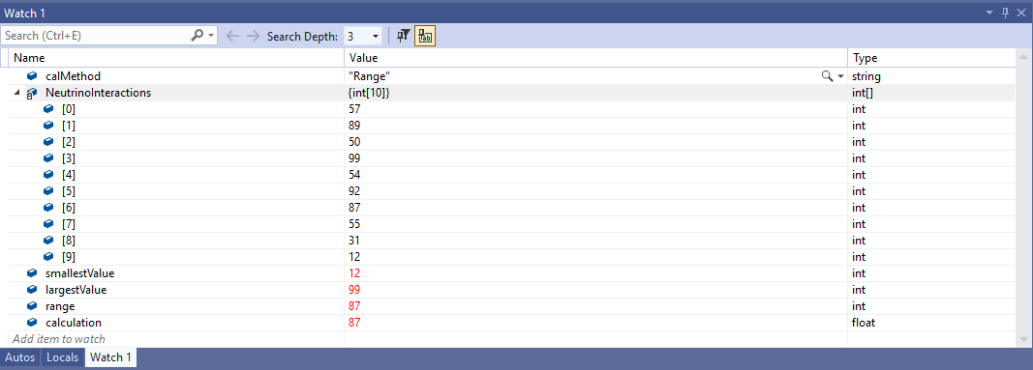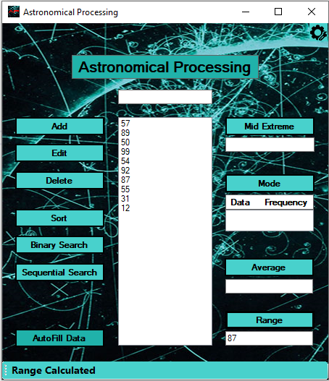

## Test Case 16

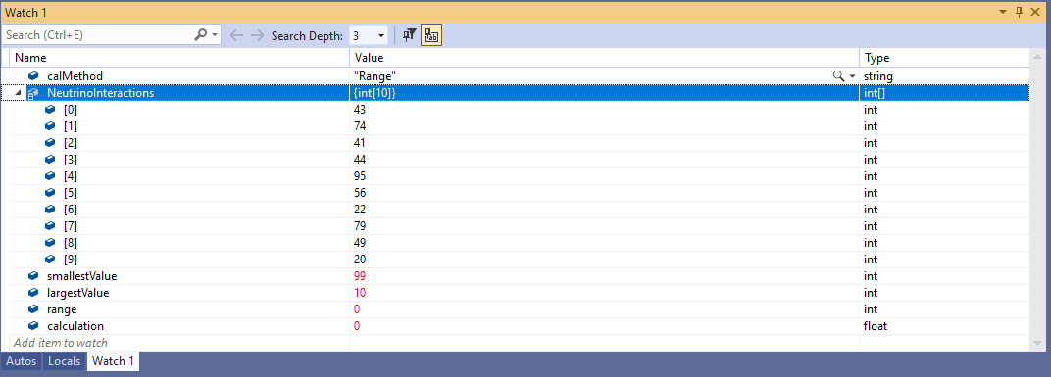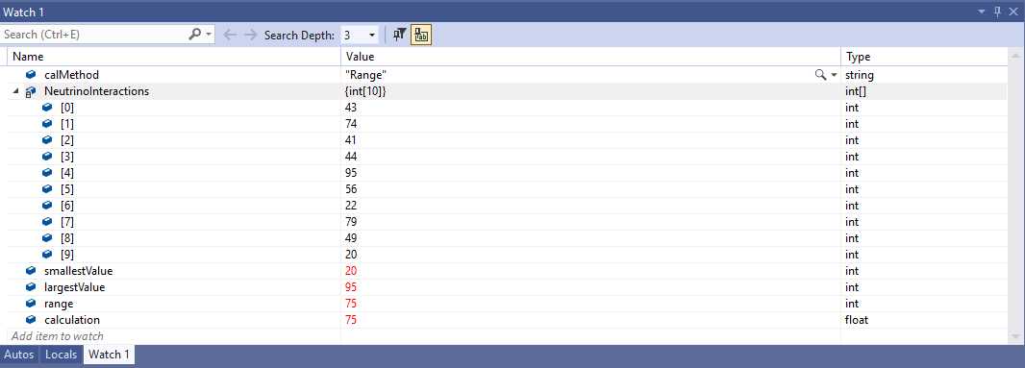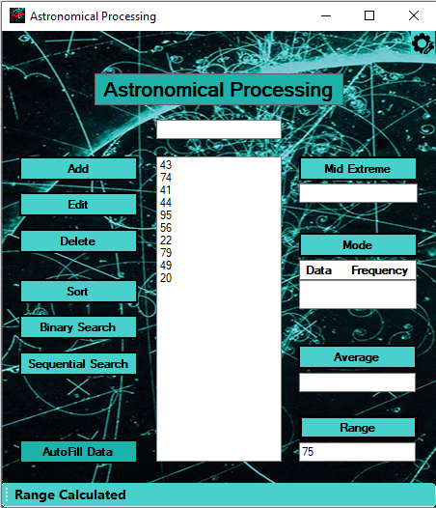

## Test Case 17

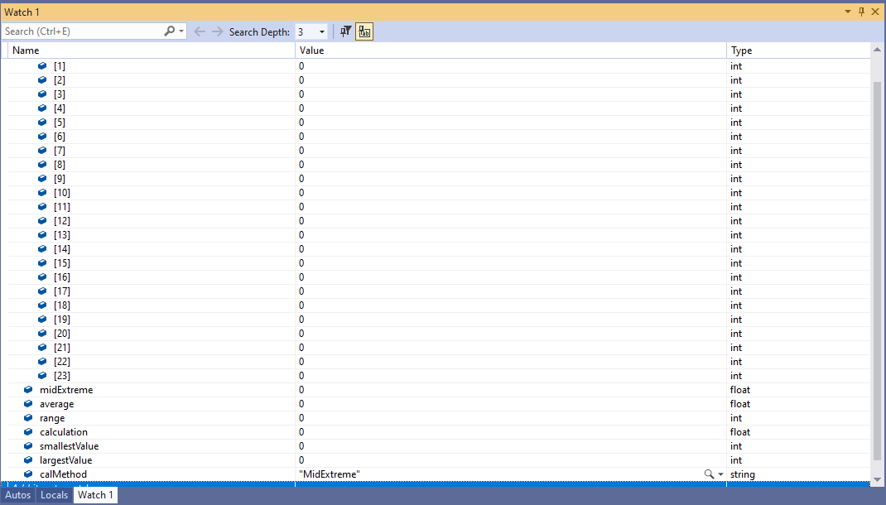

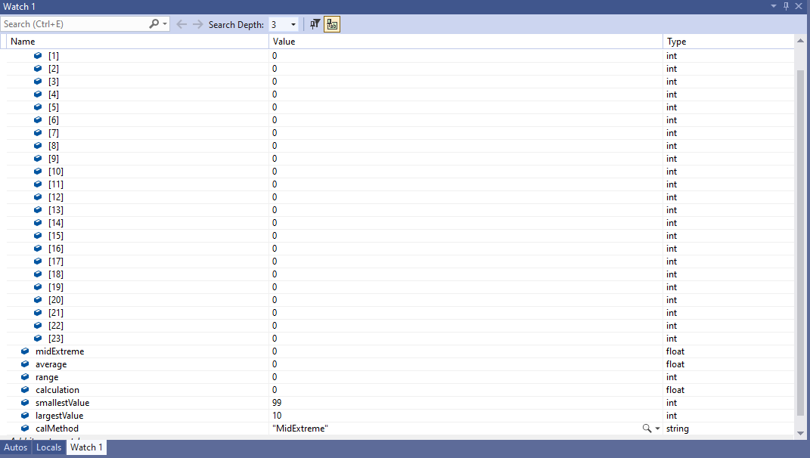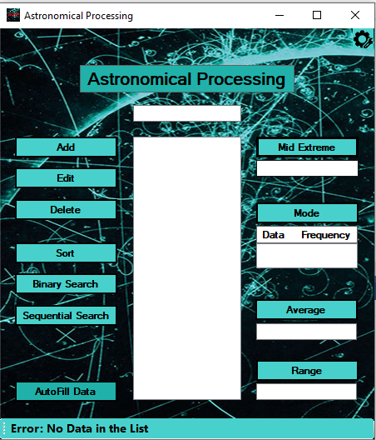

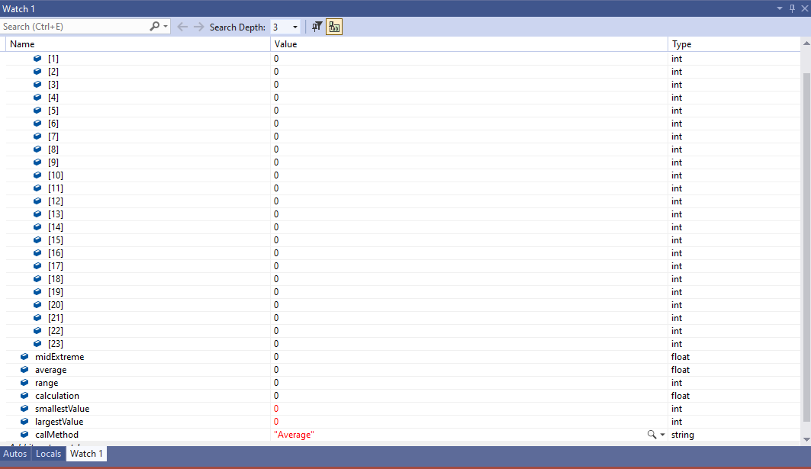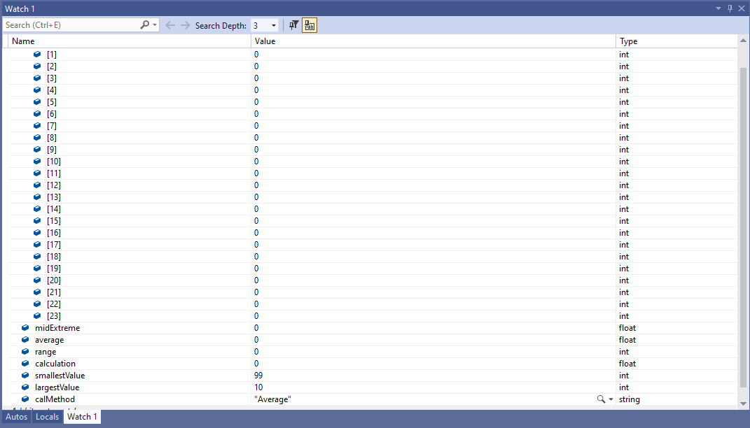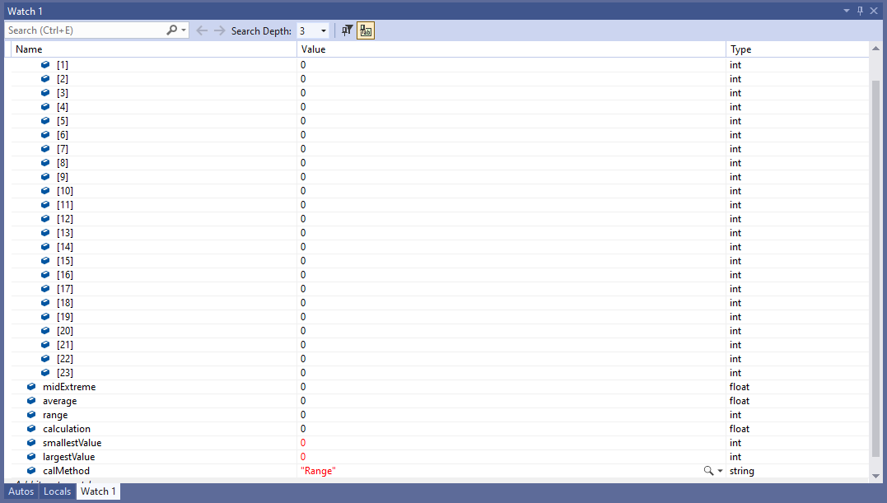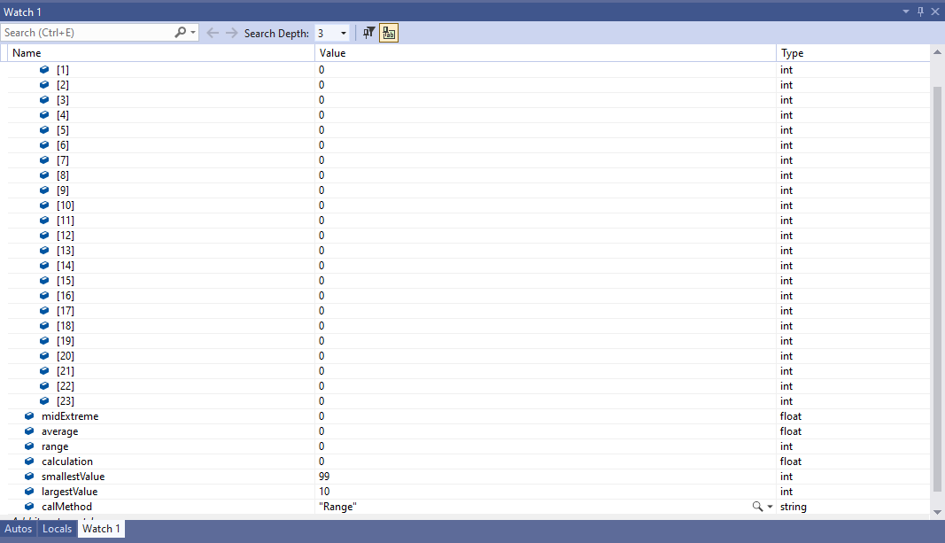

## Test Case 18

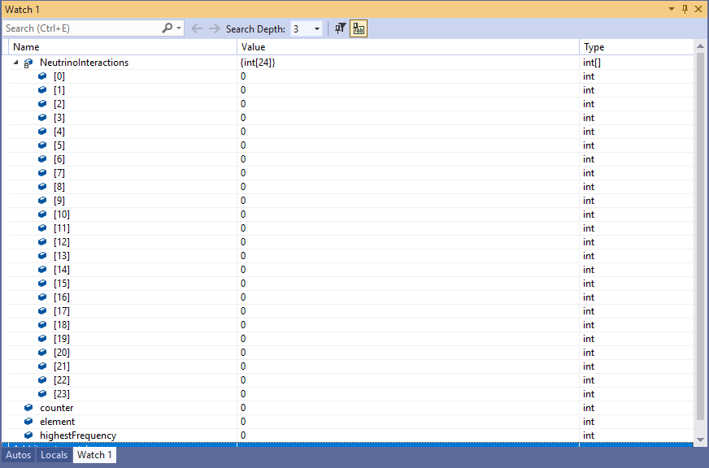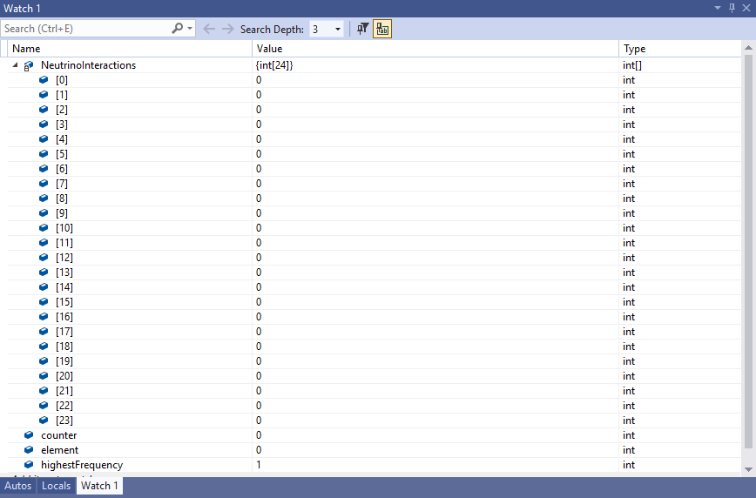

|  |  |  |  |  |  |  |  |  |
| --- | --- | --- | --- | --- | --- | --- | --- | --- |
| Test Report Two | | | | | | | | |
| Project Details | | | | | | | | |
| Date | | 14-10-2021 | | | | | | |
| Team Name | | C Blunt | | | | | | |
| Team Members | | Bruce Fisher | | | Machyl Eberle (absent) | | | |
| Test Type | | **Test all the other user functions and input**  **Reduced the Array “**NeutrinoInteractions” **to a size of 10 for testing.**  **L**ine 30 - static int ArraySize = 10; | | | | | | |
| Test Case # | Test Case Name | | Test Steps | Test Data | | Expected Results | Evidence  (ref to Screen Capture) | Pass / Fail |
| 1 | AutoFill Button | | 1. Left click on Button “AutoFill Data” | Data From Pre-fill  94, 63, 50, 31, 51, 95, 17, 59, 19, 72 | | Fills the Main List Box with Simulated Data and display a message “Data has been pre-filled” | Test Case 1 | Pass |
| 2 | Select Data from List | | 1. Left click on Data in Main List Box | 83, 17, 89, 89, 24, 26, 76, 83, 52, 63 | | Highlights selected Data in Main List Box and that Data is placed in Text Box Main | Test Case 2 | Pass |
| 3 | Sort Data in List | | 1. Left click on Button “AutoFill Data” 2. Left click on Button “Sort” | 99, 49, 11, 11, 76, 82, 57, 42, 66, 65 | | Sorts data in ascending order and displays sorted data back in list. Message displays “ | Test Case 3 | Pass |
| 4 | Binary Search – no Data in the List | | 1. Left click on Button “Binary Search | nothing | | Displays error message “No Data in the List” | Test Case 4 | Pass |
| 5 | Binary Search – no Data Selected | | 1. Left click on Button “AutoFill Data” 2. Left click on Button “Binary Search | 56, 29, 55, 18,22, 68, 97, 98, 39, 26 | | Displays error message “Error – Text box empty, please enter value to Search” | Test Case 5 | Pass |
| 6 | Binary Search – List Not Sorted | | 1. Left click on Button “AutoFill Data” 2. Left click on Data in List or enter Data to search in Text Box 3. Left click on Button “Binary Search” | 56, 29, 55, 18,22, 68, 97, 98, 39, 26 | | Display error message “Error – Please Sort list first” | Test Case 6 | Pass |
| 7 | Binary Search – List Sorted – Data not found | | 1. Left click on Button “AutoFill Data” 2. Left click on Button “Sort” 3. Enter Data in Text Box that is not listed 4. Left click on Button “Binary Search” | 18, 22, 26, 29, 39, 55, 56, 68, 97, 98  Text Box Input = “10” | | Displays message “Value NOT found: 10“ | Test Case 7 | Pass |
| 8 | Binary Search – List Sorted – Data Exists in List | | 1. Left click on Button “AutoFill Data” 2. Left click on Button “Sort” 3. Left click on Data in List or enter Data to search in Text Box that exists in Data List 4. Left click on Button “Binary Search” | 18, 22, 26, 29, 39, 55, 56, 68, 97, 98  Selected = “39” | | Displays message “Value found : 39 at index 5”  Index 5 as user does not understand index starting from 0 | Test Case 8 | Pass |
| 9 | Binary Search – List Sorted – Duplicates of Data Exists in List | | 1. Left click on Button “AutoFill Data” 2. Left click on Button “Sort” 3. Left click on Duplicated Data in List or enter Data to search in Text Box that exists in Data List 4. Left click on Button “Binary Search” | 18, 22, 22, 29, 39, 55, 56, 68, 97, 98  Selected = “22” | | Displays message “Multiple Values Found : 22 at indexes 2 to 3” | Test Case 9 | Pass |
| 10 | Sequential Search – no Data in the List | | 1. Left click on Button “Sequential Search” | nothing | | Displays error message “No Data in the List” | Test Case 10 | Pass |
| 11 | Sequential Search – no Data selected | | 1. Left click on Button “AutoFill Data” 2. Left click on Button “Sequential Search” | 47, 37, 23, 17, 42, 13, 95, 66, 90, 78 | | Displays error message “Error – Text box empty, please enter value to Search” | Test Case 11 | Pass |
| 12 | Sequential Search – Data Exists in List | | 1. Left click on Button “AutoFill Data” 2. Left click on Data in List or enter Data to search in Text Box that exists as in Data List 3. Left click on Button “Sequential Search” 4. Left click on Button “Find Next” once found | 47, 37, 23, 17, 42, 13, 95, 66, 90, 78  Selected = “95” | | Displays message “Value Found : 95 at index 7”  PLEASE NOTE – in code index is already incremented by 1 for next search | Test Case 12 | Pass |
| 13 | Sequential Search – Duplicates of Data Exists in List | | 1. Left click on Button “AutoFill Data” 2. Left click on Duplicated Data in List or enter Data to search in Text Box that exists as in Data List 3. Left click on Button “Sequential Search” 4. Left click on Button “Find Next” once found 5. Left click on Button “Find Next” once found | 47, 37, 23, 17, 42, 13, 95, 66, 90, 95  Selected = “95” | | Displays message “Value Found : 95 at index 7”  AND  Second message after NEXT search “Value Found 95 at index 10” | Test Case 13 | Pass |
| 14 | Add to blank Data List | | 1. Type into Top Main Text Box number 2. Click on the “Add” Button | 10 | | Displays message “Added Value : 10”  New Value is listed in the Main List Box | Test Case 14 | Pass |
| 15 | Add to Full Data List | | 1. Left click on Button “AutoFill Data” 2. Type into Top Main Text Box number 3. Click on the “Add” Button | 75, 16, 37, 25, 71, 57, 33, 43, 67, 91  Input = “10” | | Display message “Error – List already full, max : 10” | Test Case 15 | Pass |
| 16 | Add to List but nothing in Text Box Main | | 1. Click on the “Add” Button | nothing | | Displays message “Error – Please enter an integer 10 to 99” | Test Case 16 | Pass |
| 17 | Input invalid Data into Main Text Box | | 1. Type in the Test Data | 0 | | Displays message “Error Keypress: Please enter an integer 10 to 99” | Test Case 17 | Pass |
| 18 | Input invalid Data into Main Text Box | | 1. Type in the Test Data | a | | Displays message “Error Keypress: Please enter an integer” | Test Case 18 | Pass |
| 19a | Input invalid Data into Main Text Box | | 1. Type in the Test Data | ^c | | Displays message “Error Keypress: Please enter an integer” | Test Case 19a | FAIL |
| 19b | Input invalid cut and paste with ^v into Text Box Main | | 1. Copy and paste the test data into the Text Box Main | aA | | Expect that this will allow it to be cut and pasted into the Text Box | Test Case 19b | PASS  As expected result confirmed but FAIL invalid entry test |
| 19c | Fixed bug in code …  Input invalid Data into Main Text Box | | 1. Type in the Test Data | a | | Expect to allow ‘a’ character to be entered and no error message will be displayed | Test Case 19c | PASS  As expected result confirmed but FAIL invalid entry test |
| 19d | Fixed bug in code …  Input invalid Data into Main Text Box | | 1. Type in the Test Data | a | | Displays message “Error Keypress: Please enter an integer” | Test Case 19d | PASS |
| 19e | Fixed bug in code …  Enter Valid Data and Press “Backspace” key | | 1. Type in the Test Data 2. Press the “Backspace” key in Text Box Main | 10 | | Expect that you cannot use backspace to change the input and will display error message “Error Keypress: Please enter an integer” | Test Case 19e | PASS  As expected, result confirmed but FAIL as cannot modify any input |
| 19f | Fixed bug in code …  Enter Valid Data and Press “Backspace” key | | 1. Type in the Test Data 2. Press the “Backspace” key | 10 | | Expect it will allow for the 0 char to be deleted with the ‘backspace’ key press | Test Case 19f |  |
| 20 | Enter Integer larger than 2 digits | | 1. Type in the Test Data | 111 | | Expect that only 11 will be allow as Textbox Length is Fixed to Maximum Value allowed in Range | Test Case 20 | Pass |
| 21 | Invalid Range input  Lower Range Test | | 1. Type in the Test Data 2. Click on the “Add” Button | 9 | | Displays message “Error: Please enter an integer 10 to 99“ | Test Case 21 | Pass |
| 22 | Changed max Range to 100 and Test for Invalid input Upper Range Test | | 1. Type in the Test Data 2. Click on the “Add” Button | 101 | | Displays message “Error: Please enter an integer 10 to 100“ | Test Case 22 | Pass |
| 23 | Edit existing data selected from List Box | | 1. Type in Test Data 2. Click on the “Add” Button 3. Left mouse click on added data from List 4. Edit data to new value 11 | Add Data  “10”  Edit Data to “11” | | Displays message “Value 10 Edited to : 11” | Test Case 23 | Pass |
| 24 | Changed max Range to 100 and Test for Invalid input Upper Range Test.  Edit exiting data selected from list Box but attempt to change to out of Upper and Lower Range. | | 1. Type in Test Data 2. Click on the “Add” Button 3. Left mouse click on added data from List 4. Edit data to new value “101” | Add Data  “10”  Edit Data to “101” | | Displays message “Error: Please enter an integer 10 to 100“ | Test Case 24 | Pass |
| 25 | Edit data that does not exist by entering Value in Text Box Main | | 1. Type in Test Data 2. Click on the “Add” Button 3. Enter data “11” into Text Box Main. 4. Left click on “Edit” Button | Add Data  “10”  Edit Data Entered into Text Box Main “11” | | Displays Error Message “Error: Please select exiting value from list” | Test Case 25 | Pass |
| 26 | Delete existing data selected from the List Box.  And confirm delete | | 1. Type in Test Data 2. Click on the “Add” Button 3. Left mouse click on added data from List 4. Left click on “Delete” Button 5. Left click on “Yes” to confirm the delete | 10 | | Displays Message Box to confirm Delete “Yes or No?”  Upon selecting “Yes” delete the value from the list  Displays message “Deleted Value : 10” | Test Case 26 | Pass |
| 27 | Delete existing data selected from the List Box  And reject delete | | 1. Type in Test Data 2. Click on the “Add” Button 3. Left mouse click on added data from List 4. Left click on “Delete” Button 5. Left click on “No” to confirm the delete | 10 | | Displays Message Box to confirm Delete “Yes or No?”  Upon selecting “No” to NOT delete the value from the list  Displays message “Did NOT Delete Value : 10” | Test Case 27 | Pass |
| 28 | Delete data that does not exist by entering Value in Text Box Main | | 1. Type in Test Data 2. Click on the “Add” Button 3. Enter data “11” into Text Box Main. 4. Left click on “Delete” Button | Add Data  “10”  Delete Data Entered into Text Box Main “11” | | Displays Error Message “Error: Please select exiting value from list” | Test Case 28 | Pass |
| 29 | System Config for Range of Input valid Range changed | | 1. Left click on the top right Config “Icon” Button 2. Change Text Box Min to value 3. Left click on “Save” Button | 1 | | Changes Min Range input | Test Case 29 | Pass |
| 30 | System Config for Range of Input valid Range change but Min Range larger than Max Range | | 1. Left click on the top right Config “Icon” Button 2. Change Text Box Min to value 3. Left click on “Save” Button | 1000 | | Displays Error Message “Error: Min cannot be greater than or equal to Max“ | Test Case 30 | Pass |

## Test Case 1

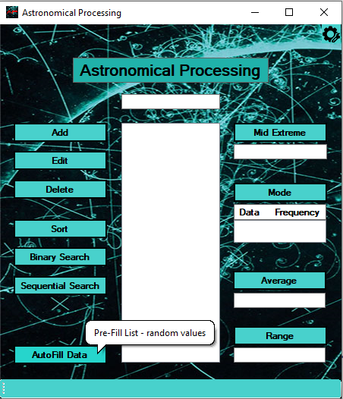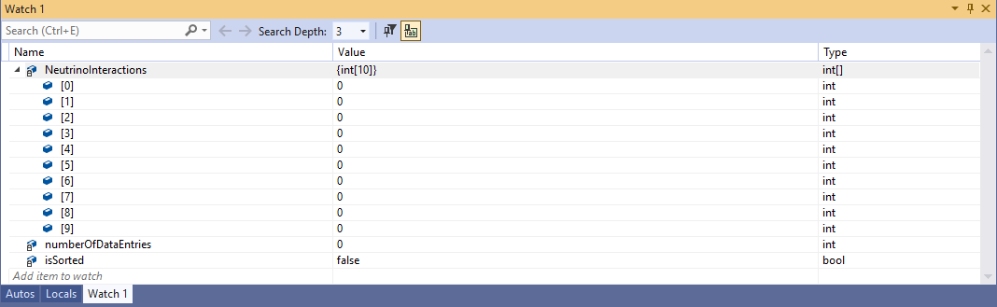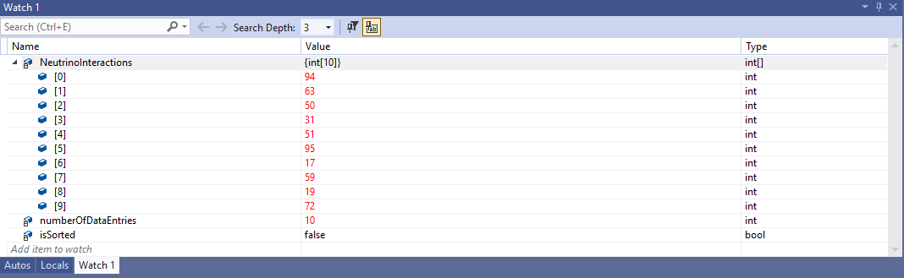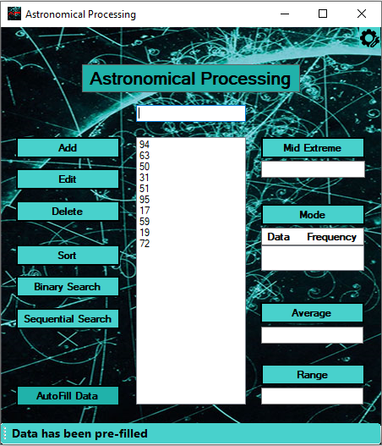

## Test Case 2

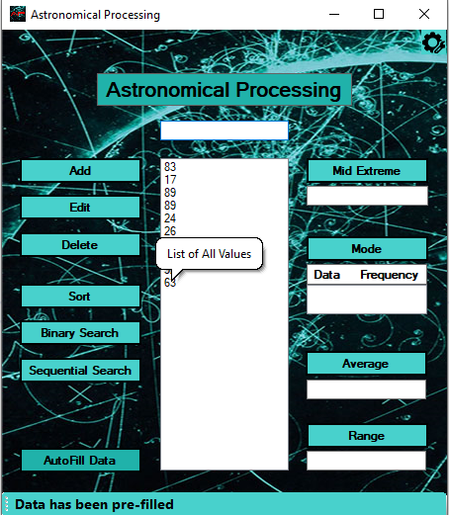

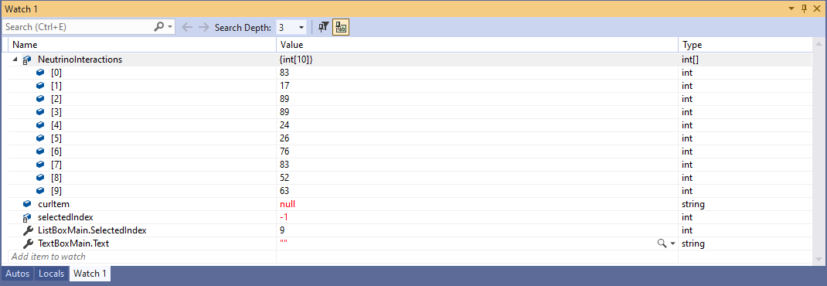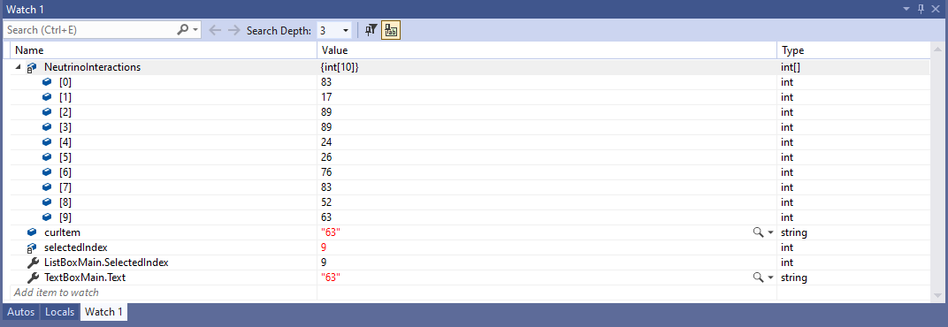

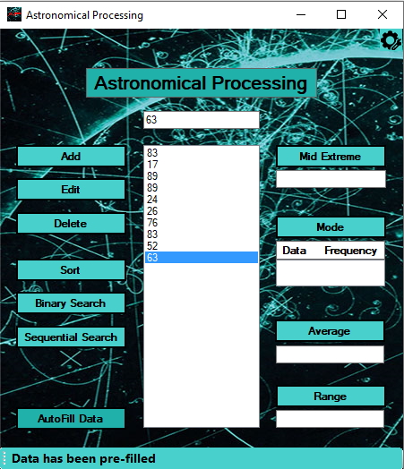

## Test Case 3

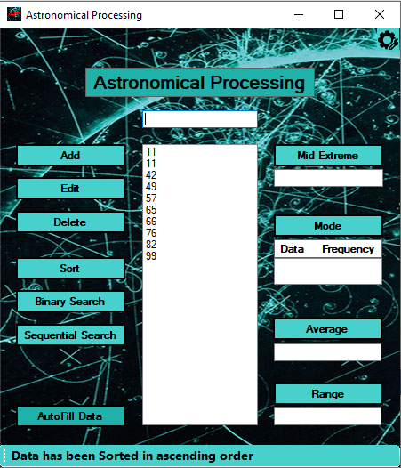 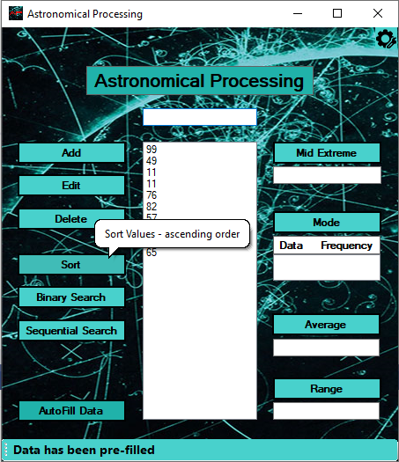

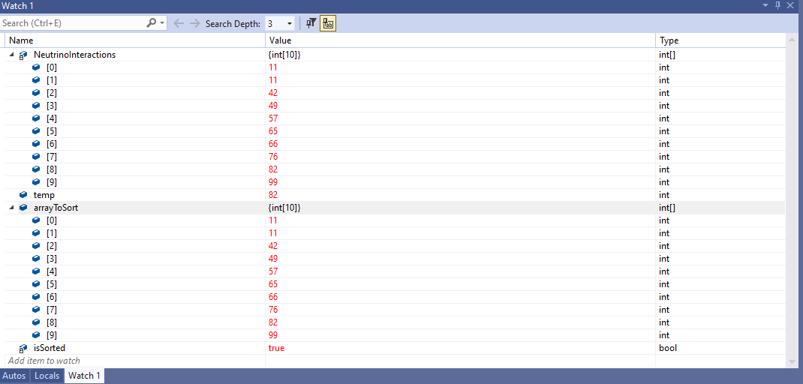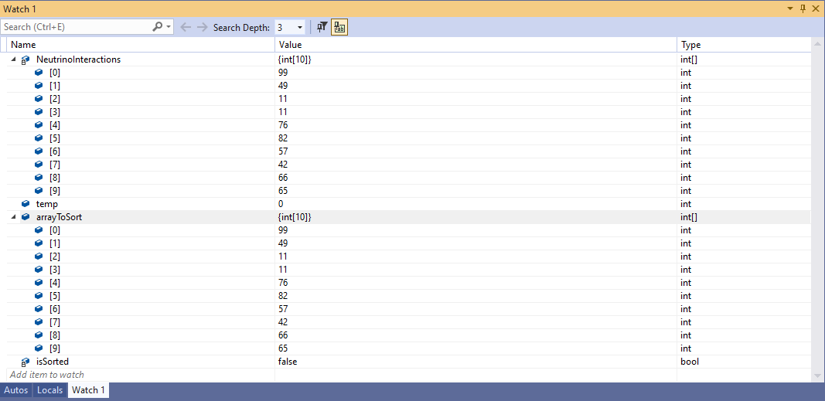

## Test Case 4

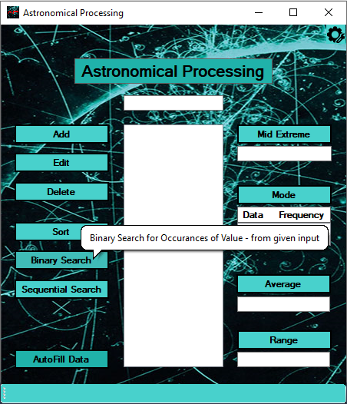

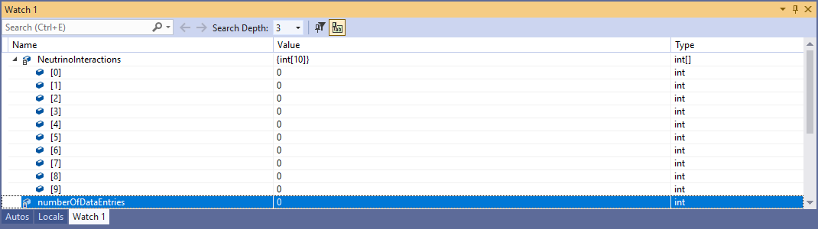

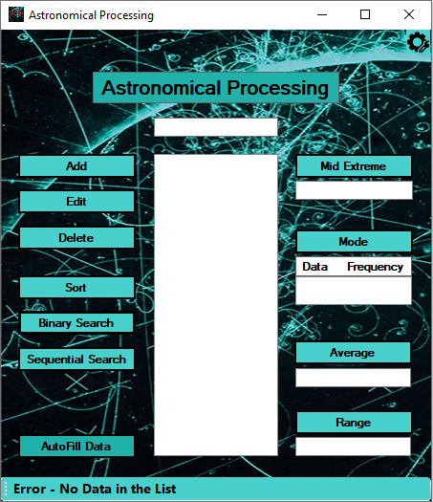

## Test Case 5

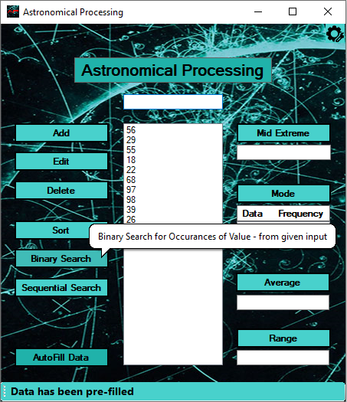

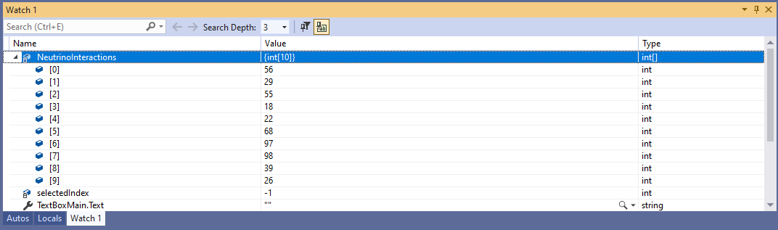

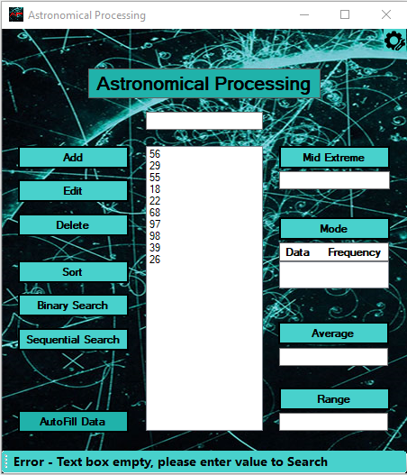

## Test Case 6



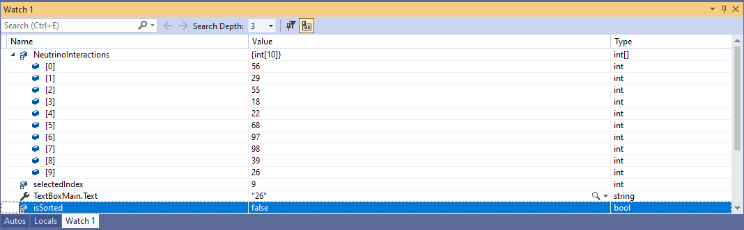

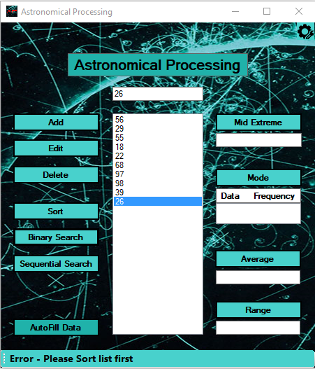

## Test Case 7

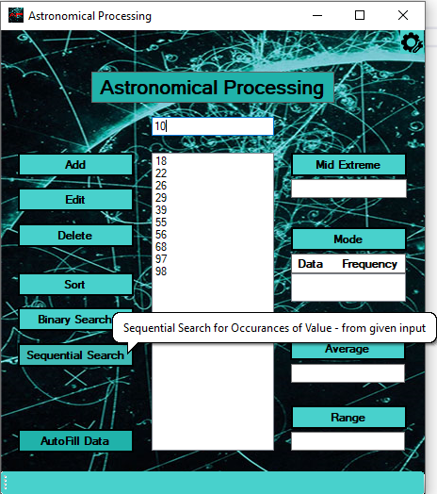 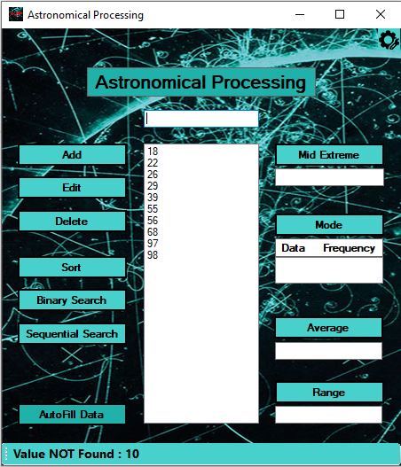

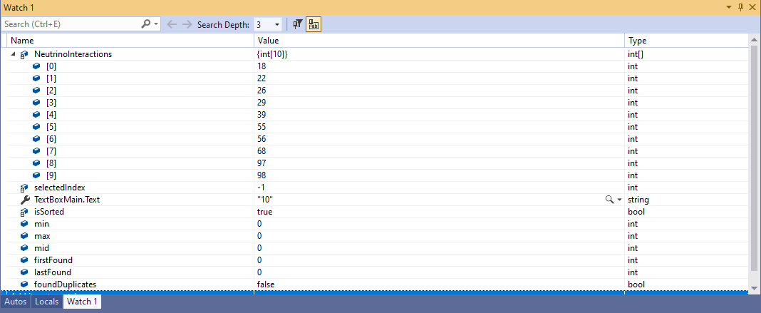

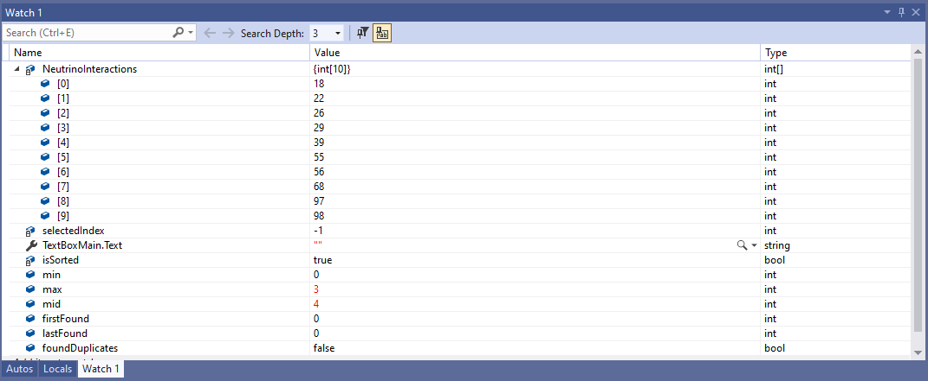

## Test Case 8

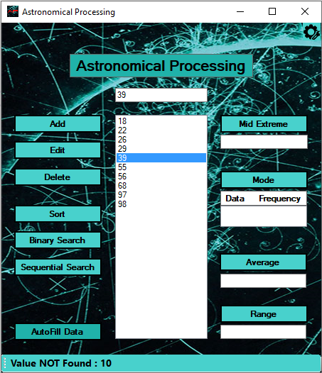 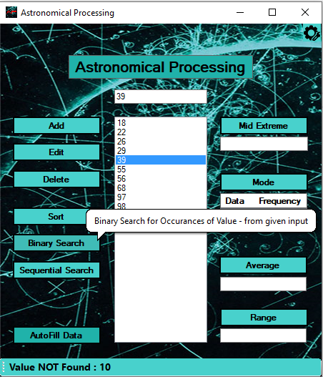

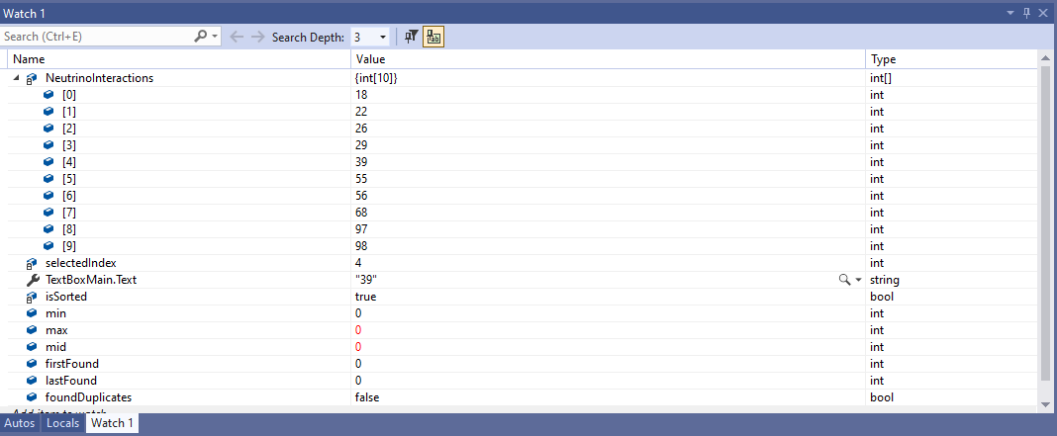

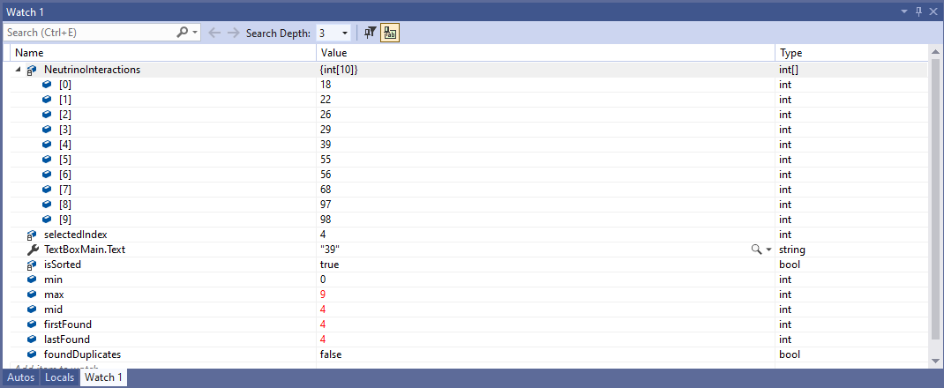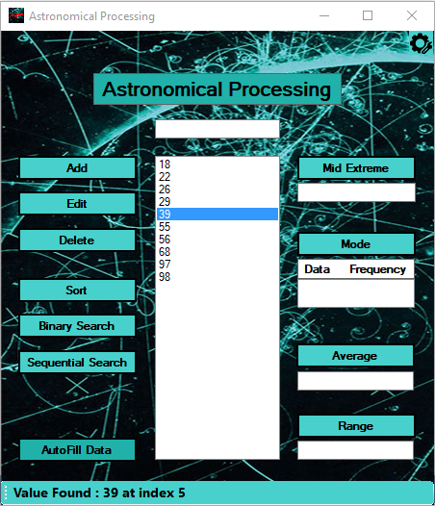

## Test Case 9

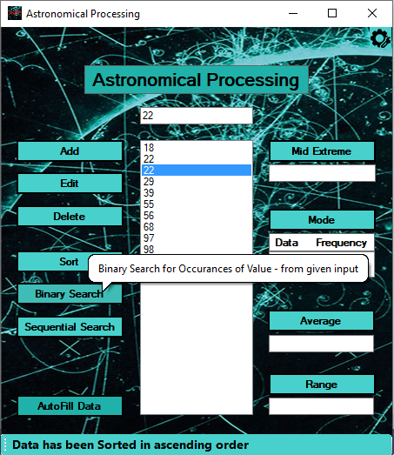 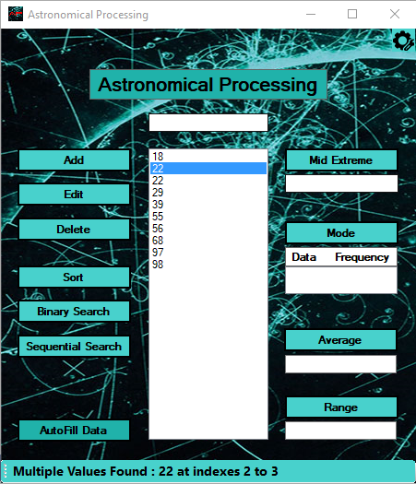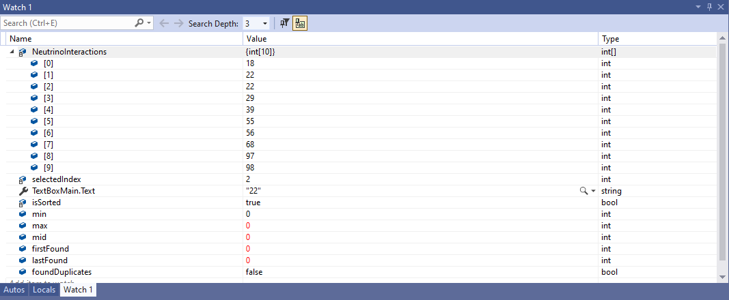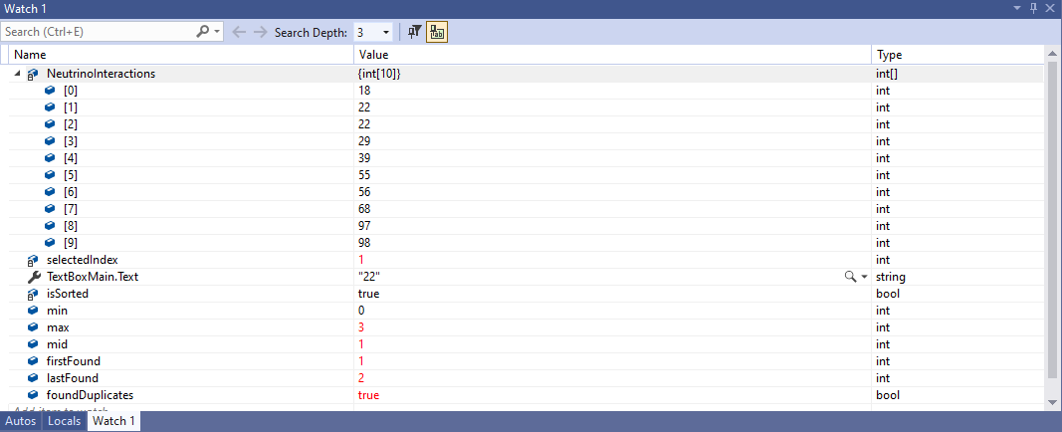

## Test Case 10

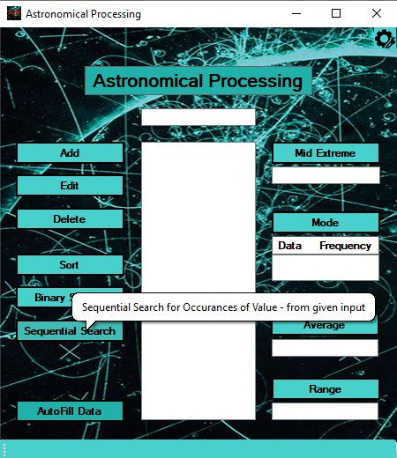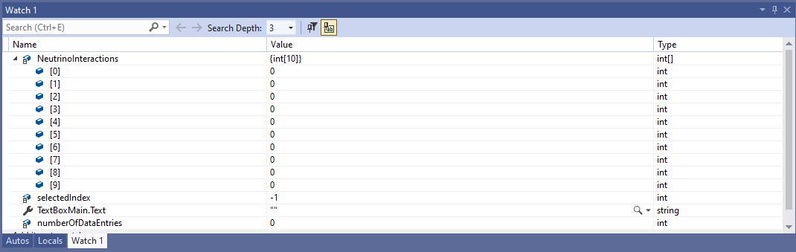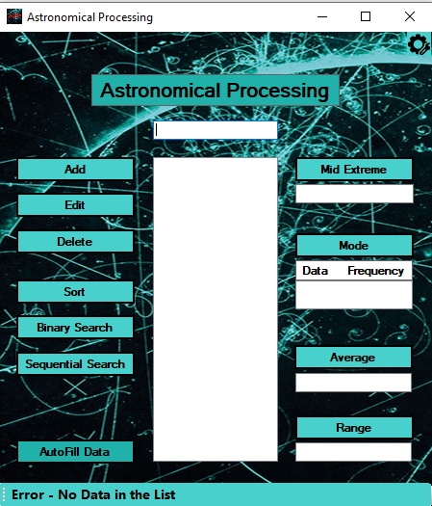

## Test Case 11

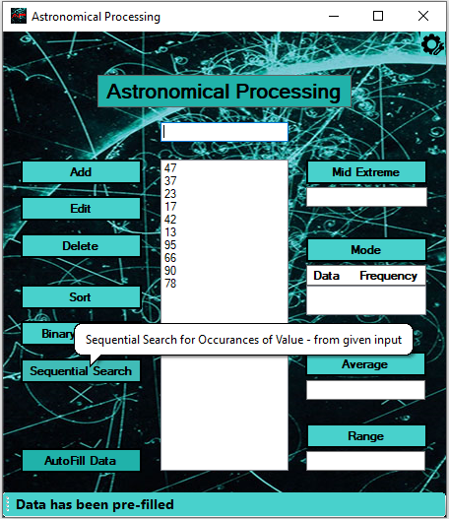

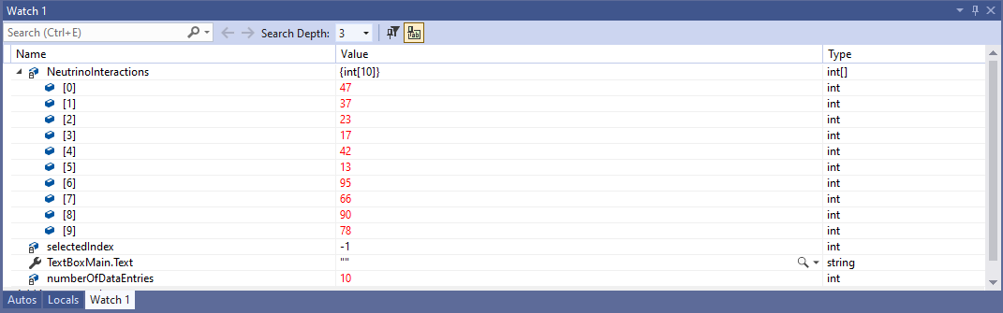

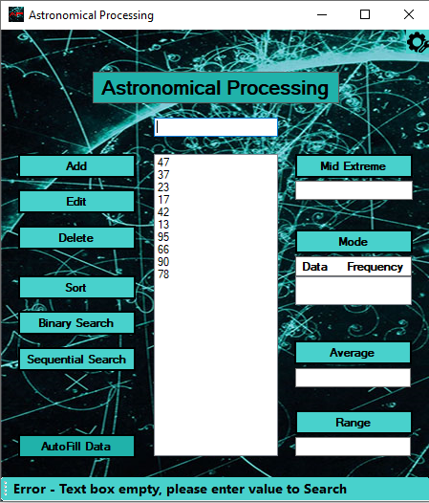

## Test Case 12

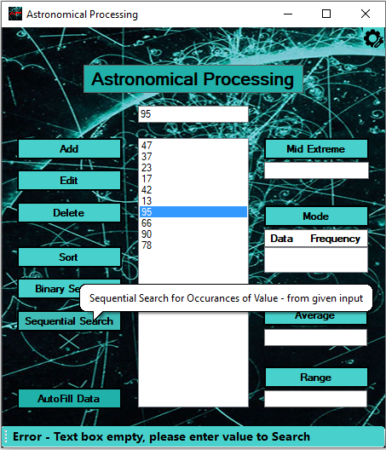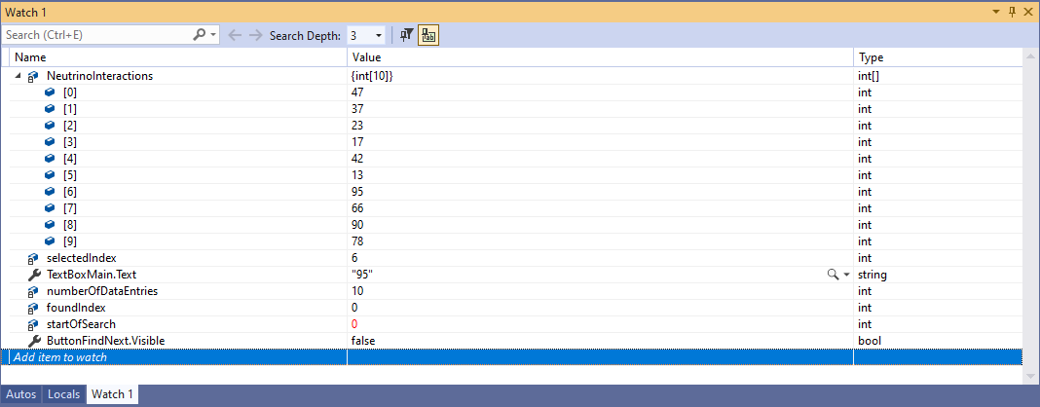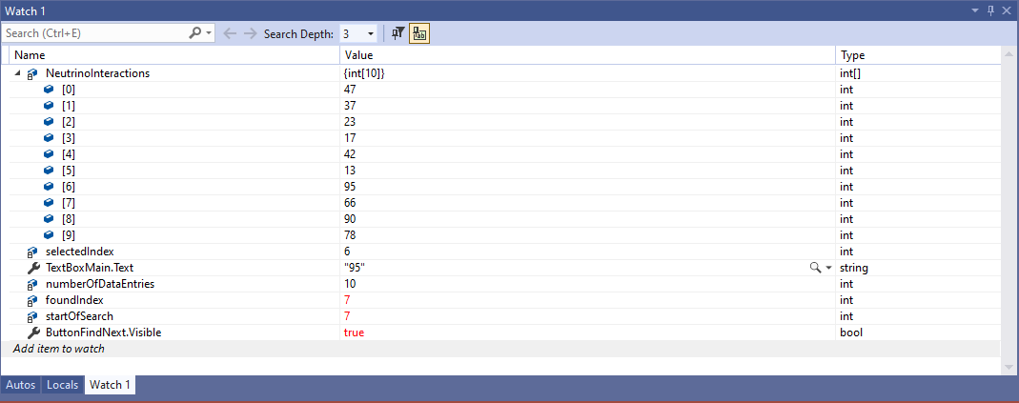

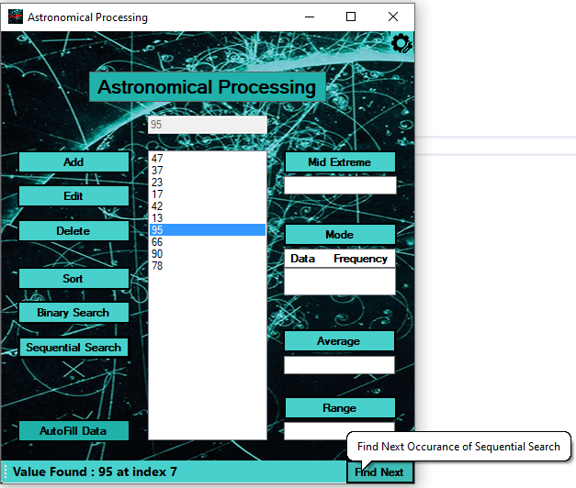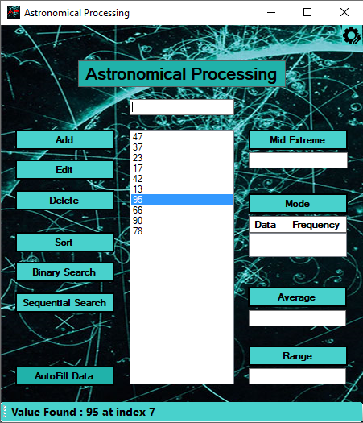

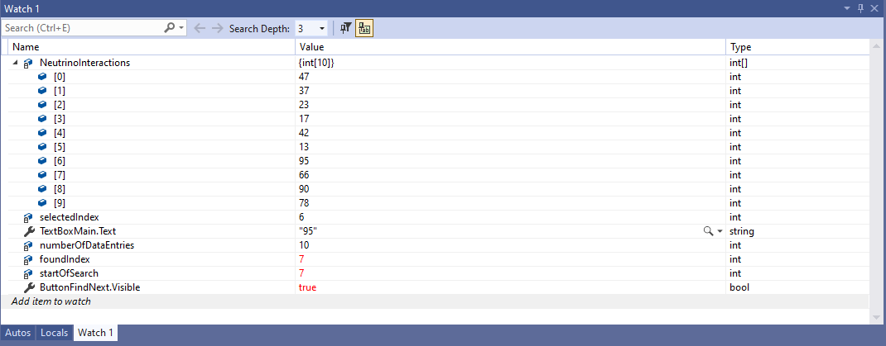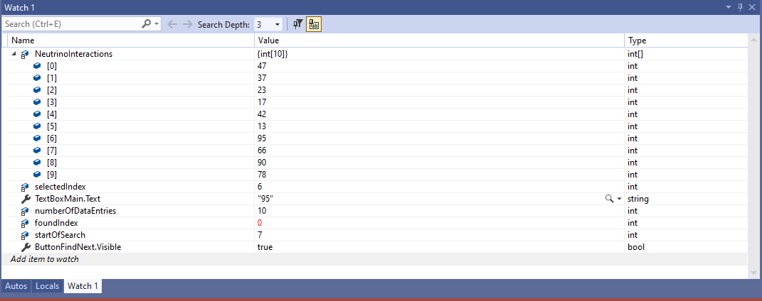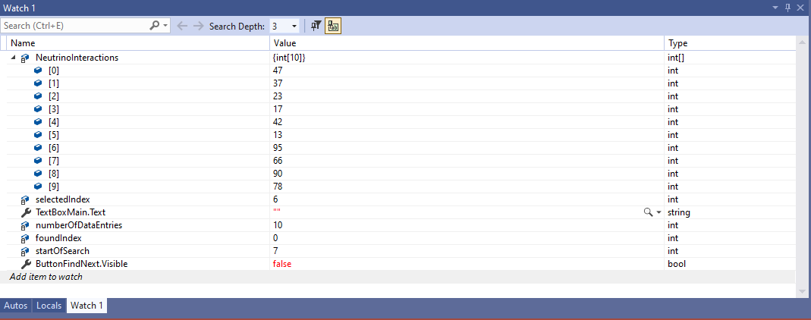

## Test Case 13

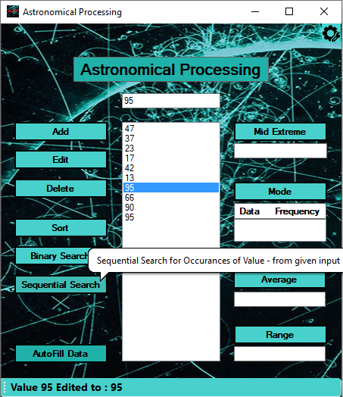

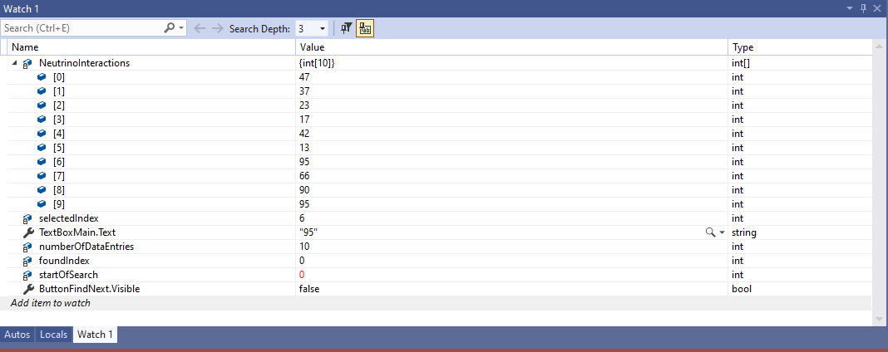

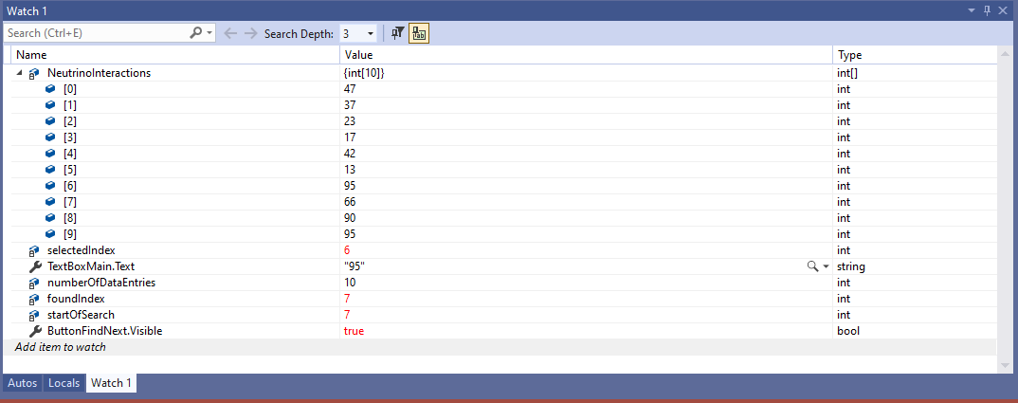

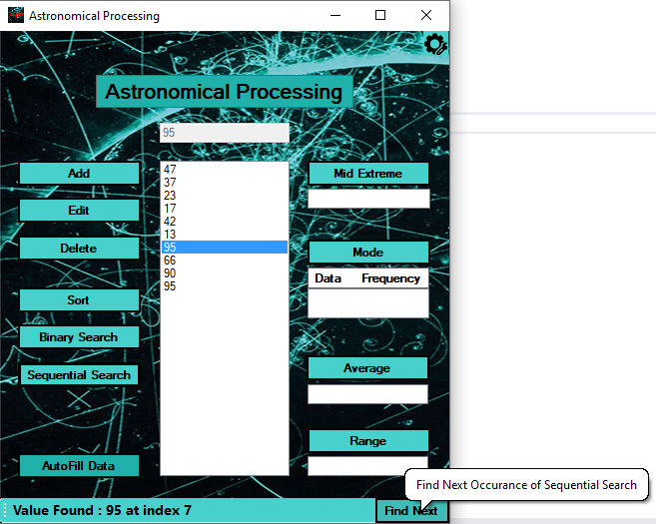

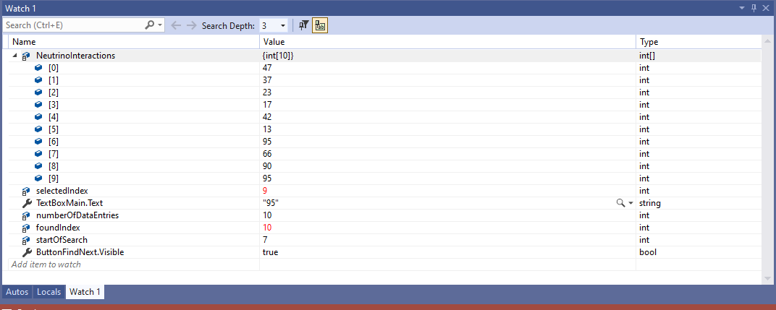

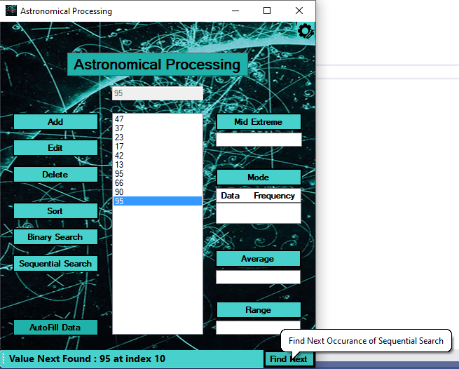

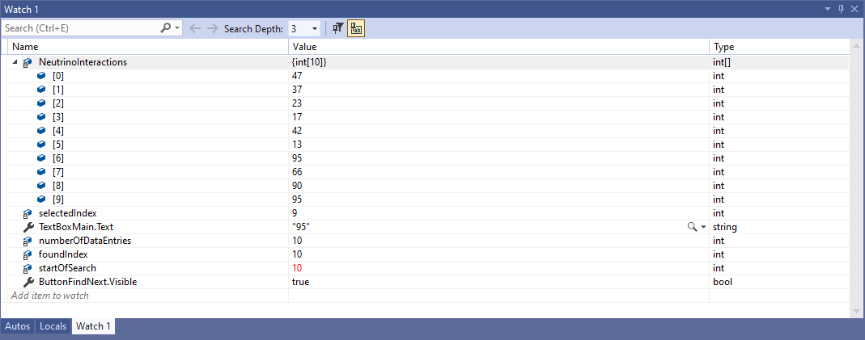

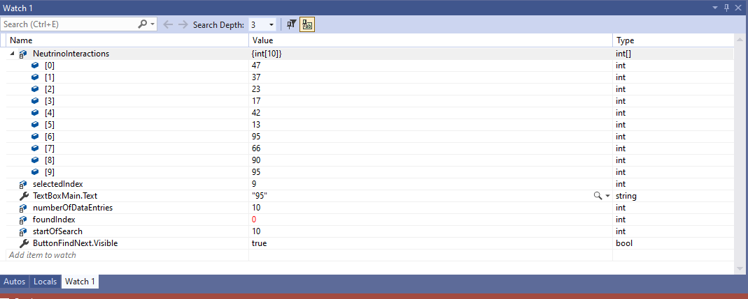

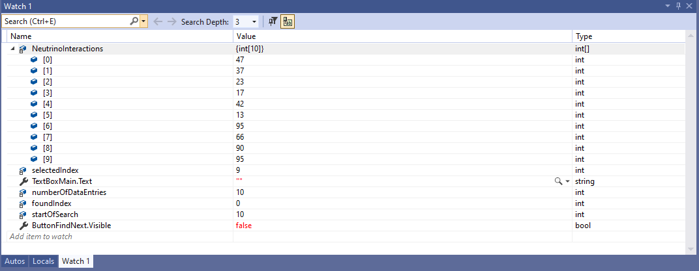

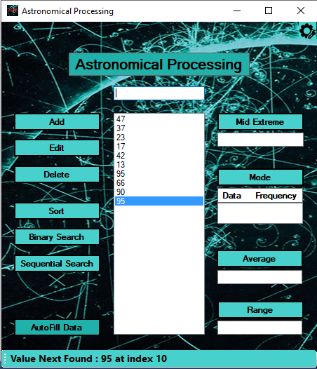

## Test Case 14

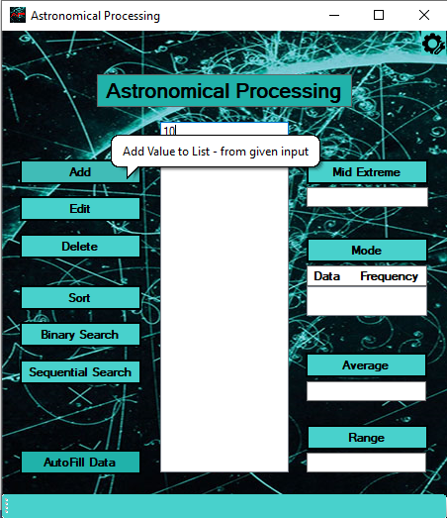 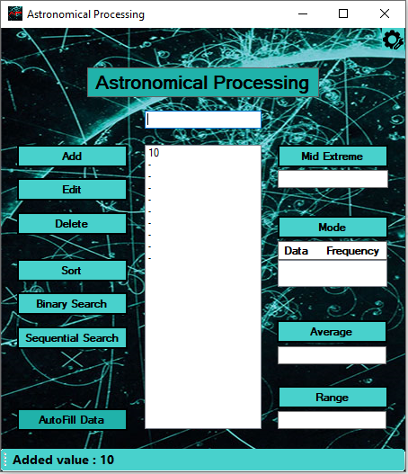

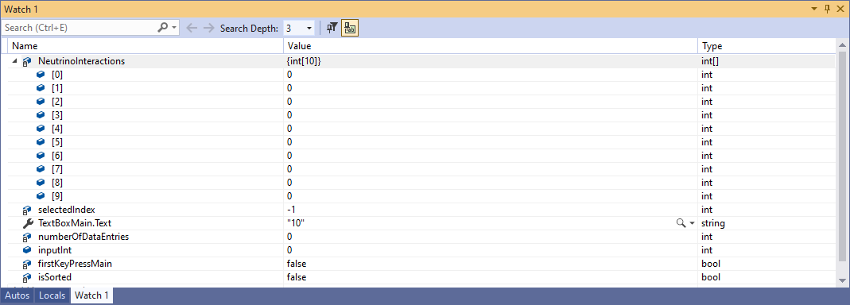

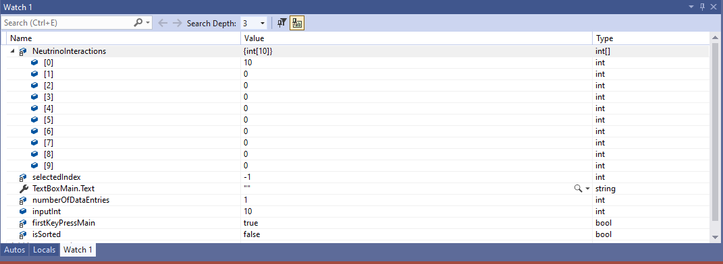

## Test Case 15

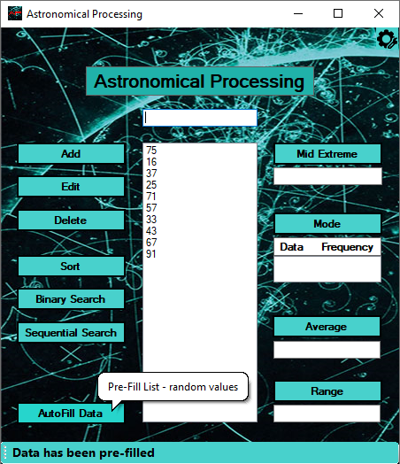 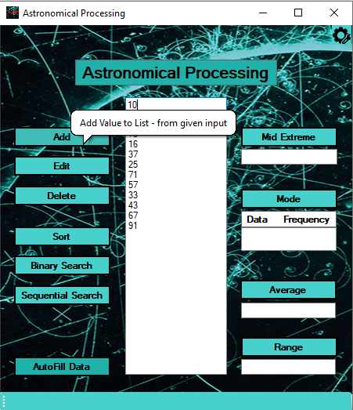

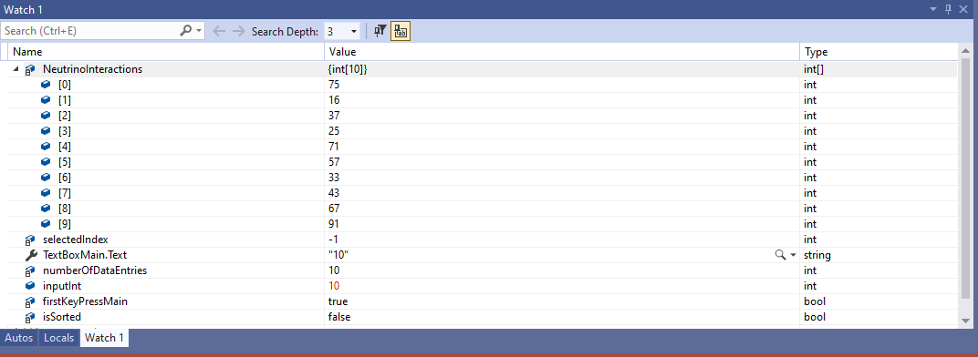

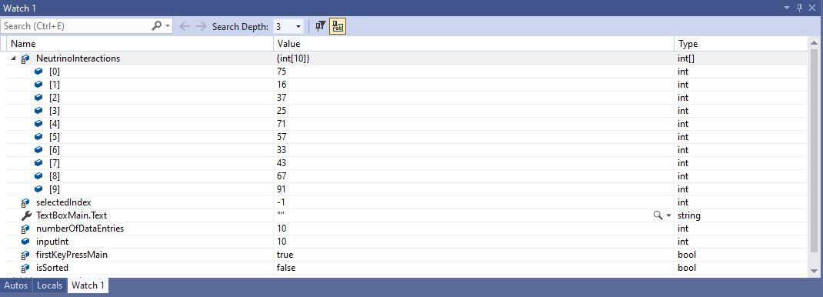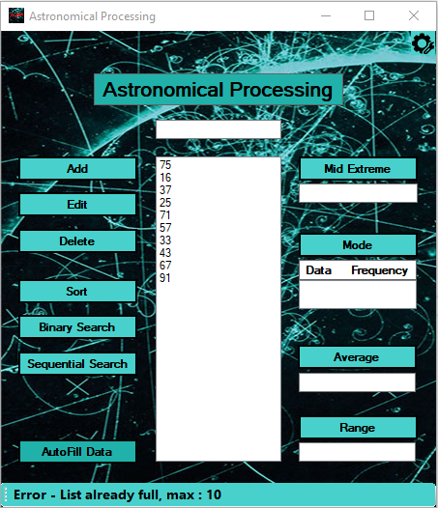

## Test Case 16

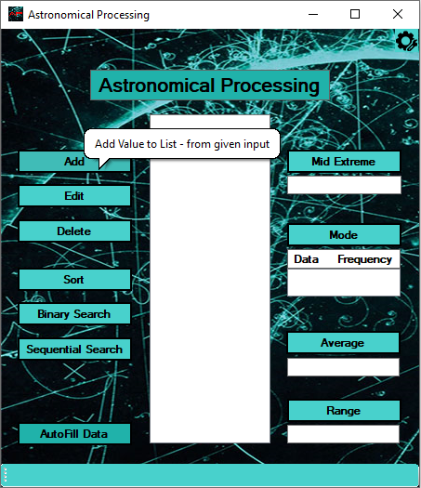 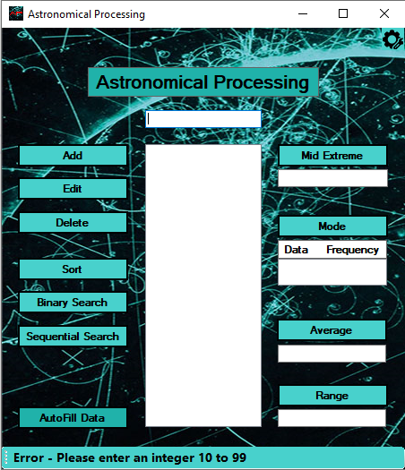

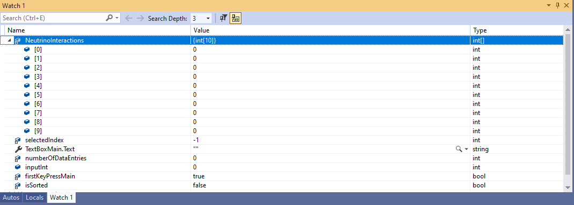

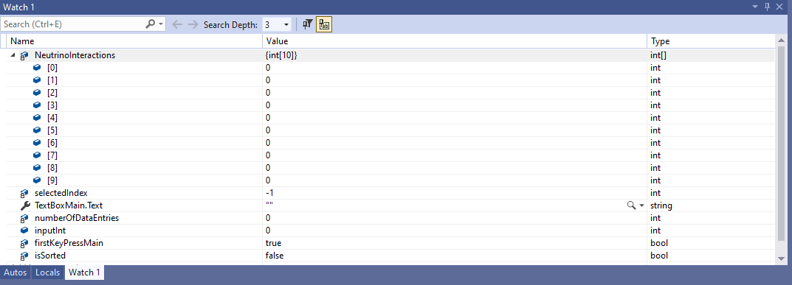

## Test Case 17

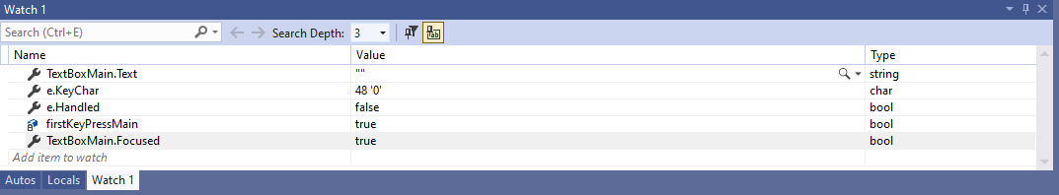

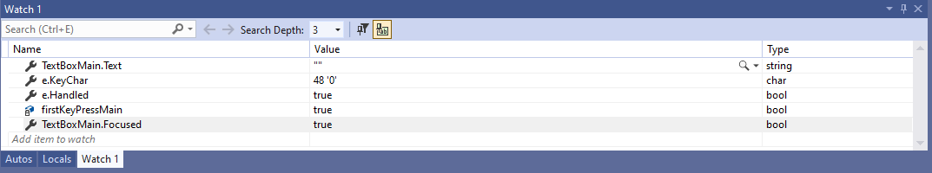

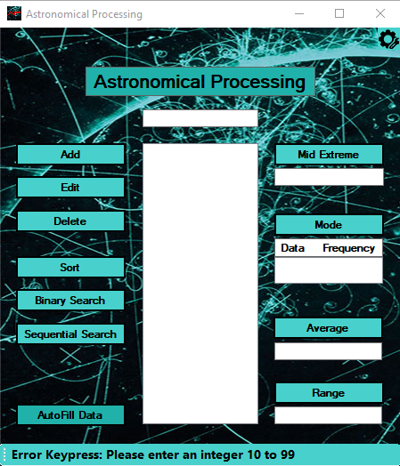

## Test Case 18

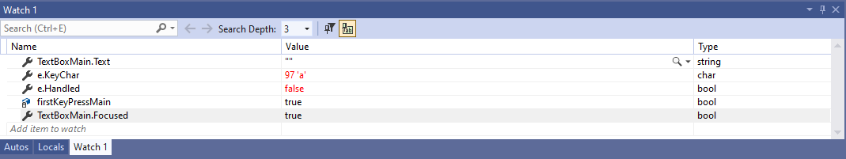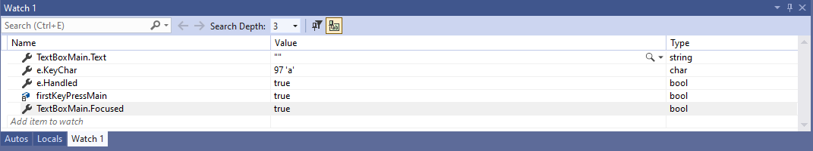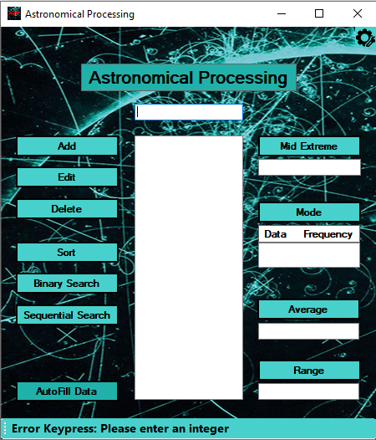

## Test Case 19a & 19b & 19c – FAIL… 19d – PASS

## Test Case 19a

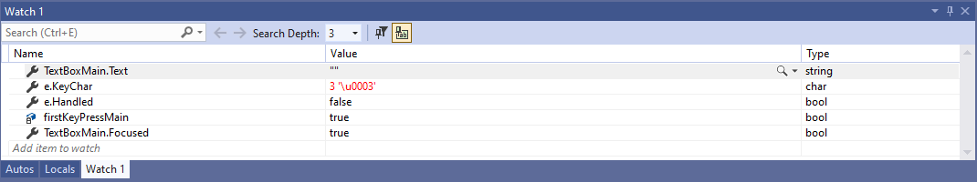

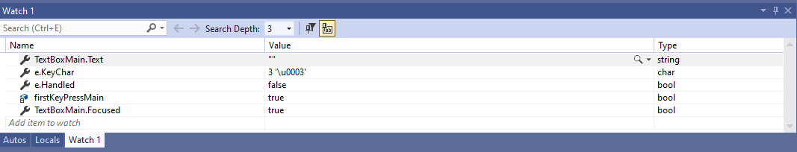

Did Not Trap ^c

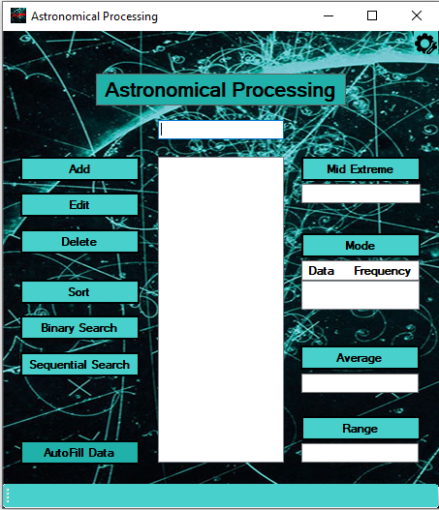

No Error Message

As allows for ^ characters can be used therefore you would also be allowed to cut and paste with ^v anything into the text box

## Test Case 19b – FAIL

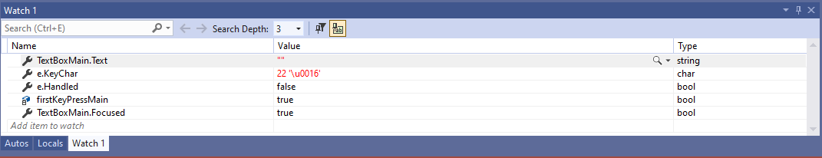

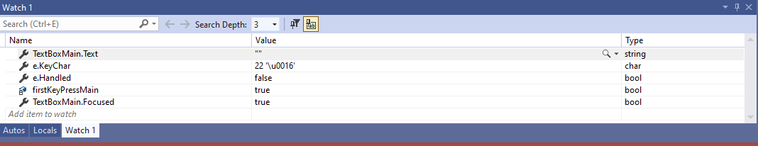

Did Not Trap ^v

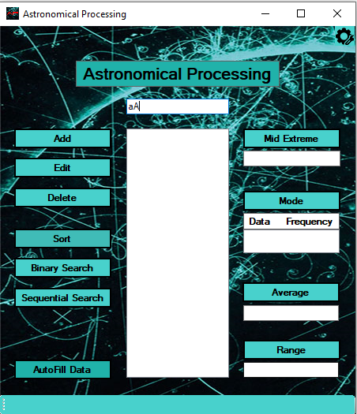

Allowed ‘aA’ to copied and pasted in

Modified Code Line 897

Old Line…

if (!char.IsControl(e.KeyChar) && !char.IsDigit(e.KeyChar))

New Line… Changed Boolean Logic for IsControl BUT I know this will still not work correctly for IsDigit as BOTH cannot be true when entering alphabetical character.

Used a && (instead of required || for two logic operators … see next test)

if (char.IsControl(e.KeyChar) && !char.IsDigit(e.KeyChar))

Re-tested AFTER above changes made …

## Test Case 19c – FAIL

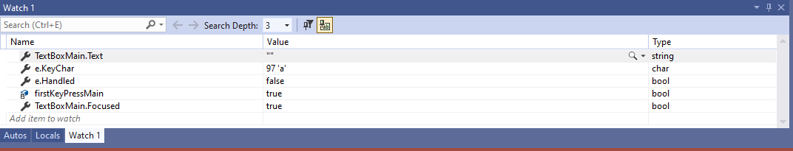

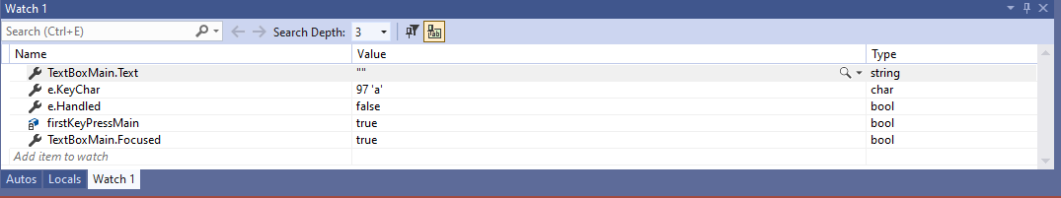

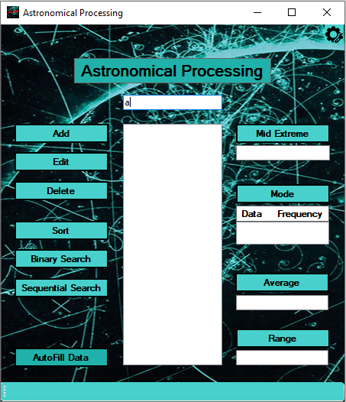

No Error Message

Allowed ‘a’ to be entered

Modified Code Line 897

Old Line…

if (char.IsControl(e.KeyChar) && !char.IsDigit(e.KeyChar))

New Line… Changed Logic from using && to || for two logic operators

if (char.IsControl(e.KeyChar) || !char.IsDigit(e.KeyChar))

This will also Fail the invalid data test as reading the code the second part will no longer allow for a ‘backspace’ to be pressed ... thus, user cannot modify the input

## Test Case 19d – PASS

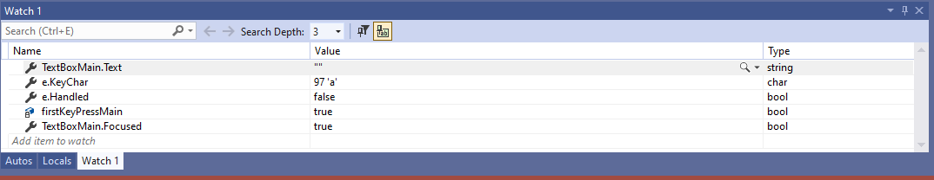

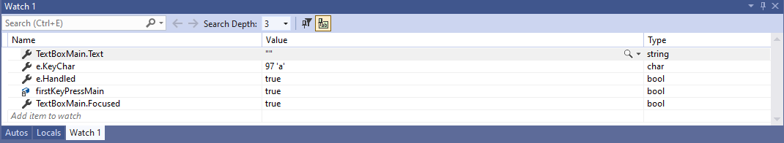

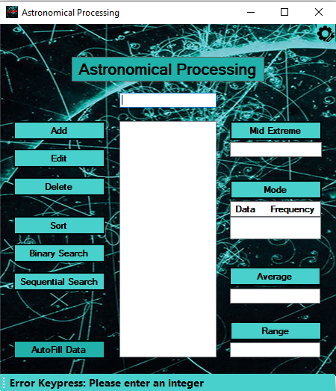

## Test Case 19e – FAIL

Skipped input of 10 steps and pressed ‘backspace’ screenshots follow from there …

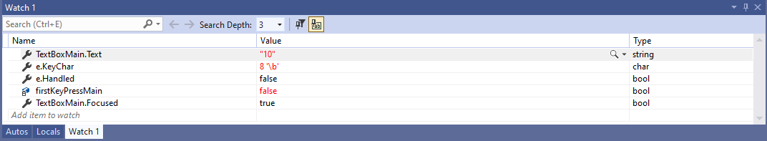

‘backspace’ keypress

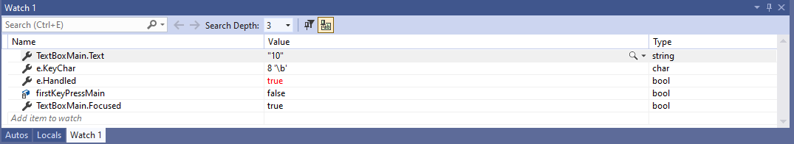

Stopped ‘backspace’ keypress

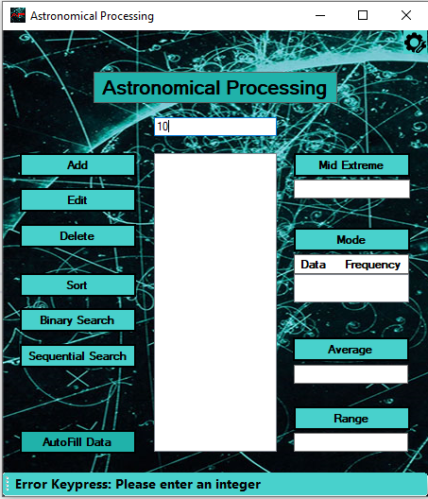

WRONG Error Message

Stopped ‘backspace’ keypress

## Test Case 19f – PASS (fixed all keypress errors)

Modified Code Line 897

Old Line…

if (char.IsControl(e.KeyChar) || !char.IsDigit(e.KeyChar))

New Line… Added extra logic to line && e.KeyChar != ((char)Keys.Back)

This now allows the ‘backspace’ key to passed and be applied to the Text Boxes

if ((char.IsControl(e.KeyChar) || !char.IsDigit(e.KeyChar)) && e.KeyChar != ((char)Keys.Back))

Skipped input of 10 steps and pressed ‘backspace’ screenshots follow from there …

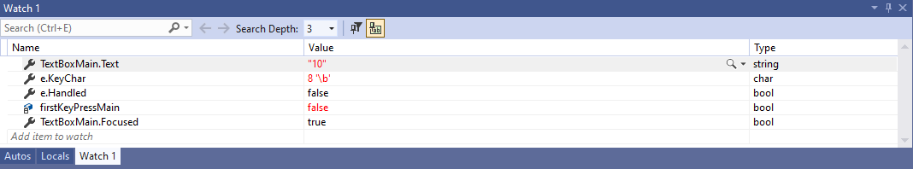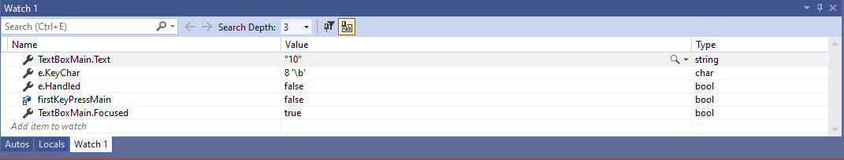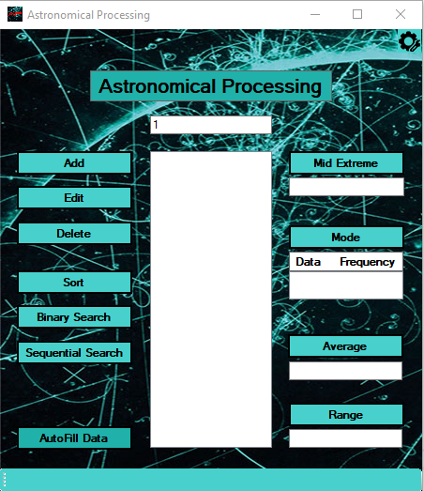

‘backspace’ keypress

Allowed ‘backspace’ keypress

Allowed ‘backspace’ keypress

## Test Case 20

Skipped steps entering first two digits 11 … to third digit entered 1…

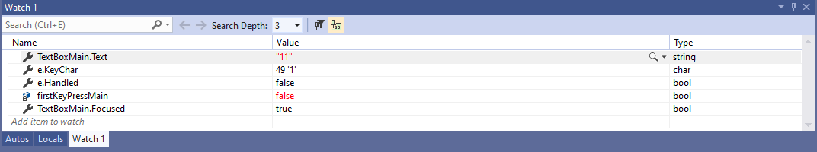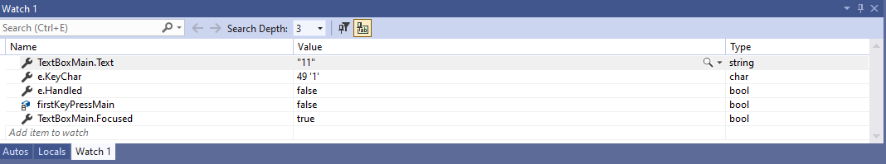

Third Digit ‘1’

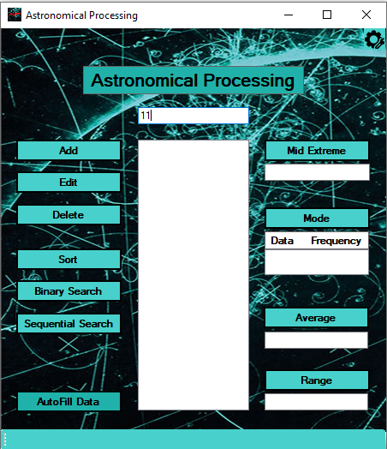

Stopped Third Digit being Entered

## Test Case 21

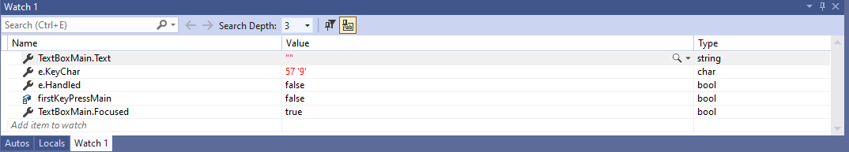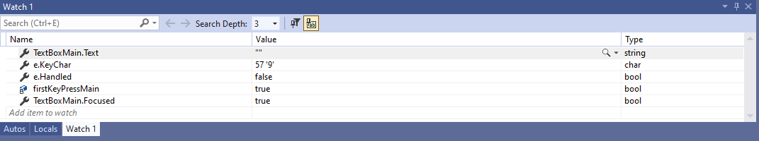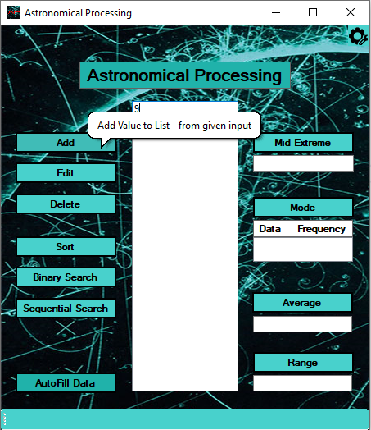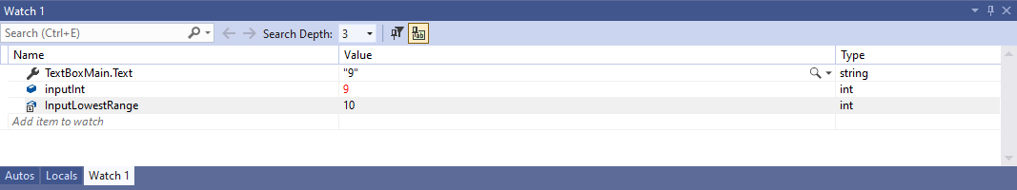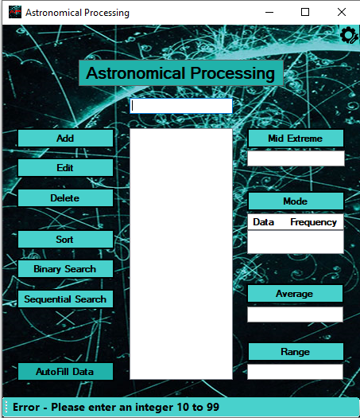

## Test Case 22

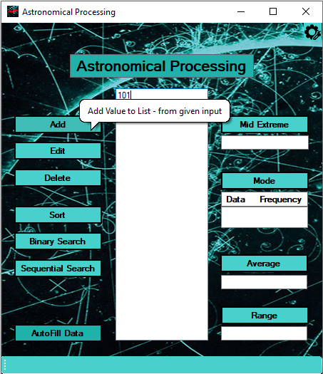 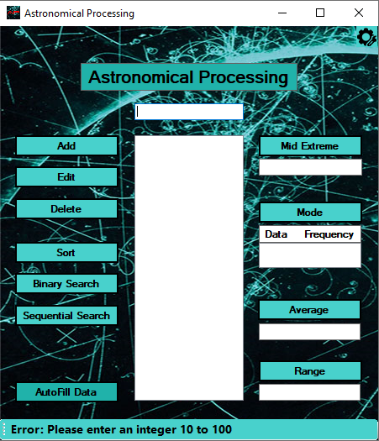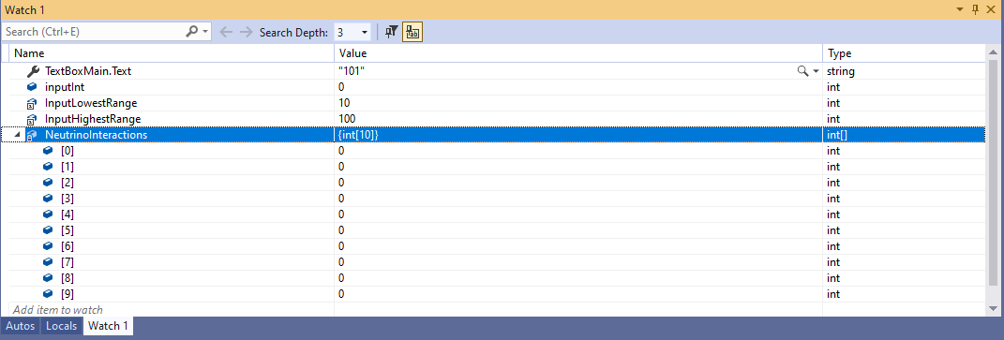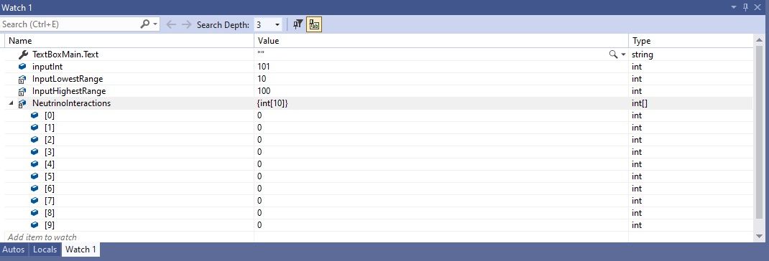

## Test Case 23

Skipped steps entering first two digits 10 and clicking Add button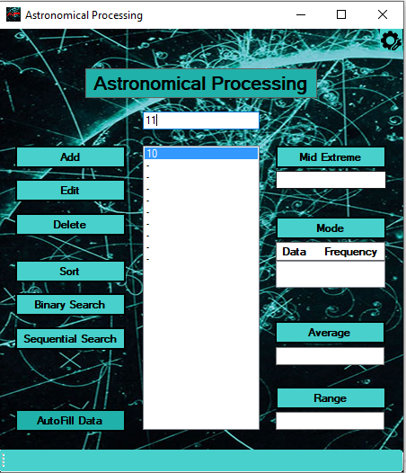 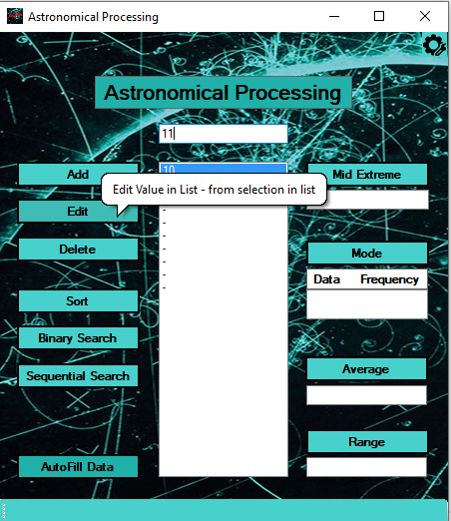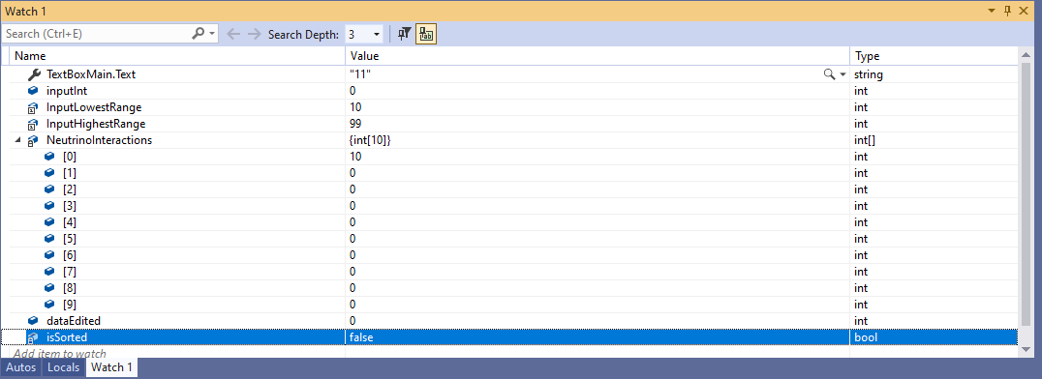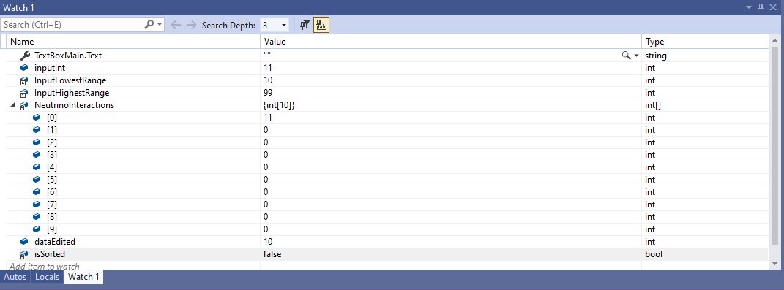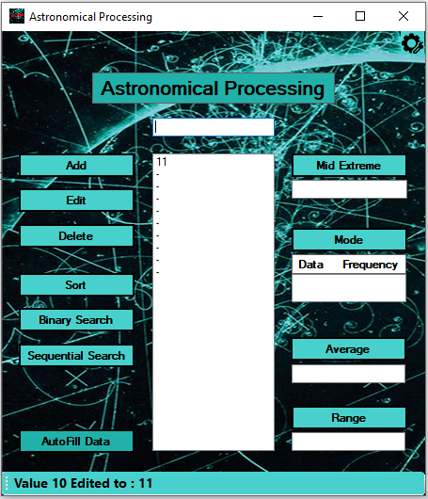

## Test Case 24

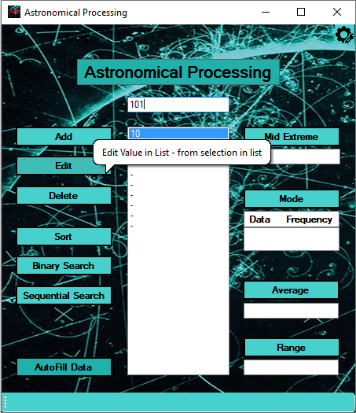 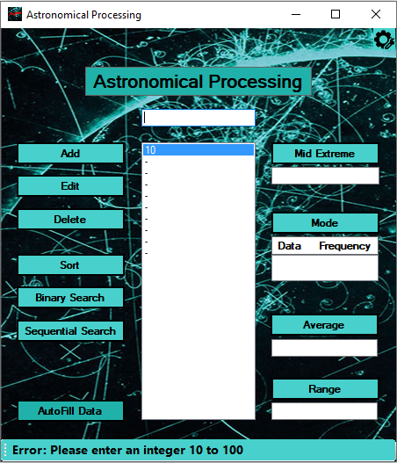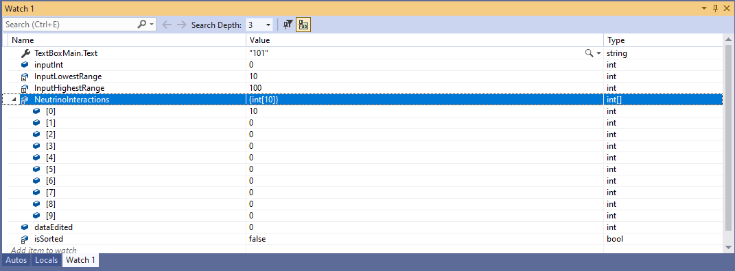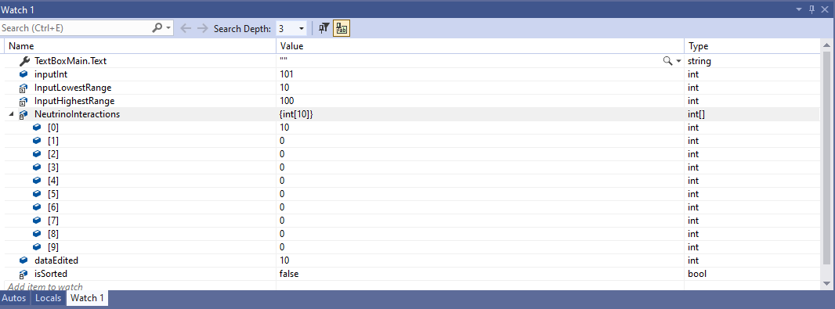

## Test Case 25

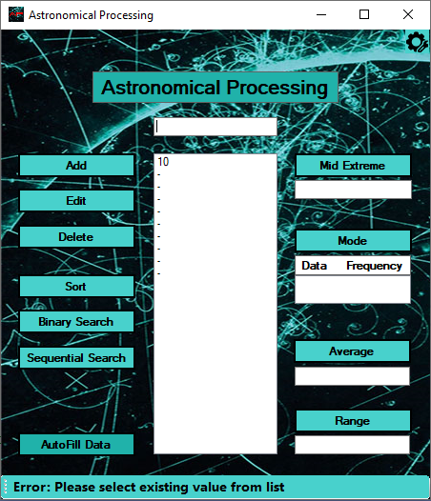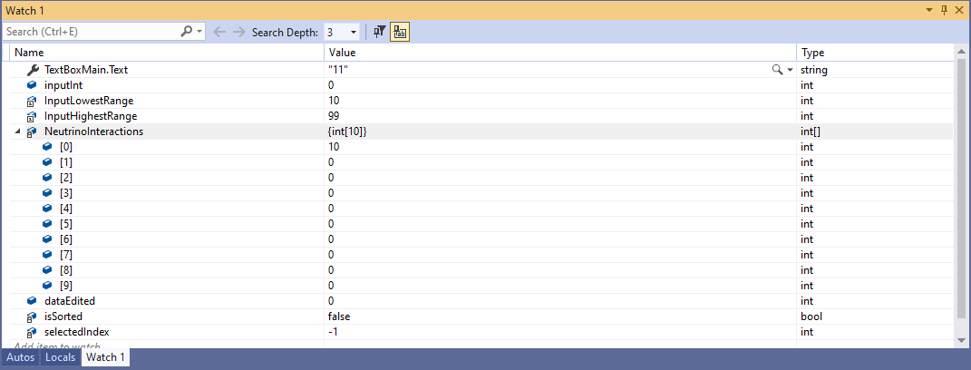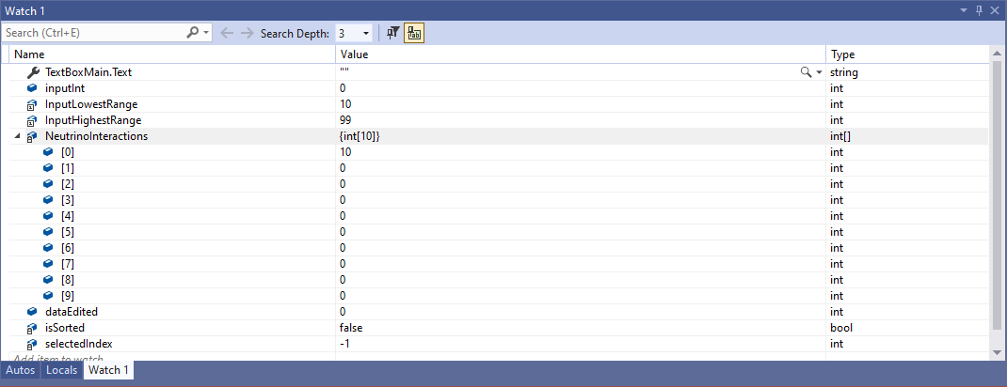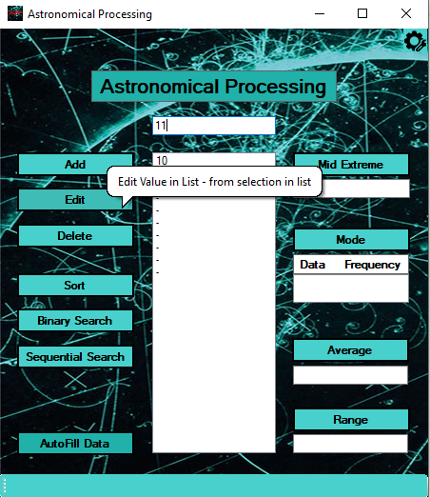

## Test Case 26

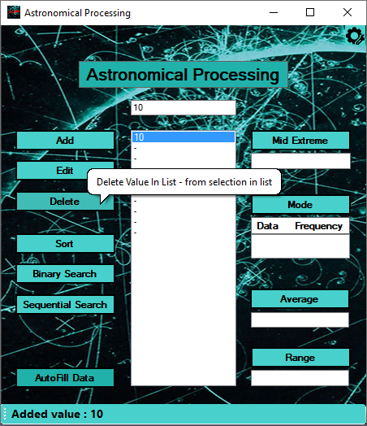 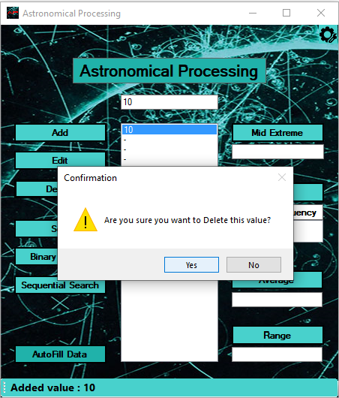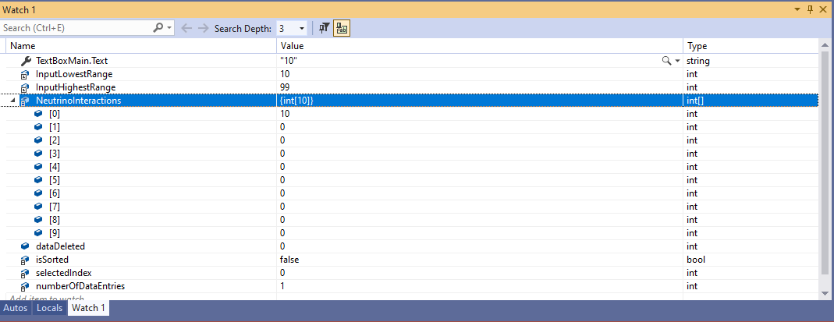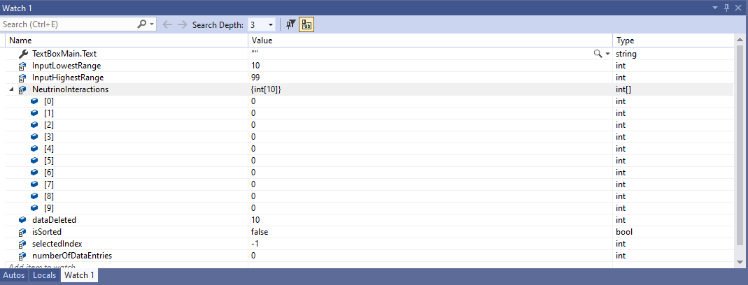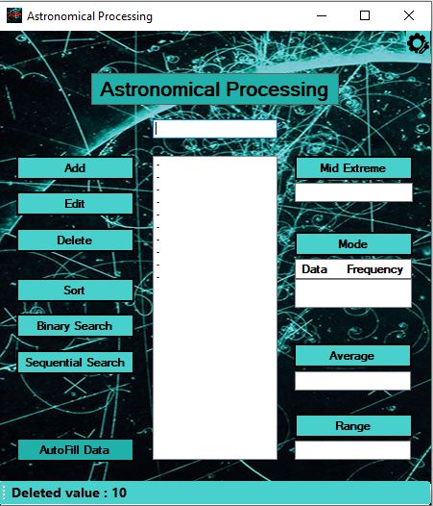

## Test Case 27

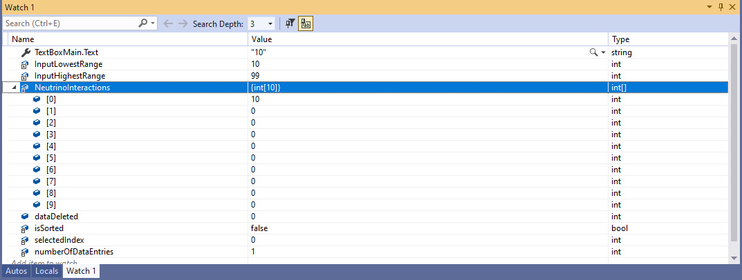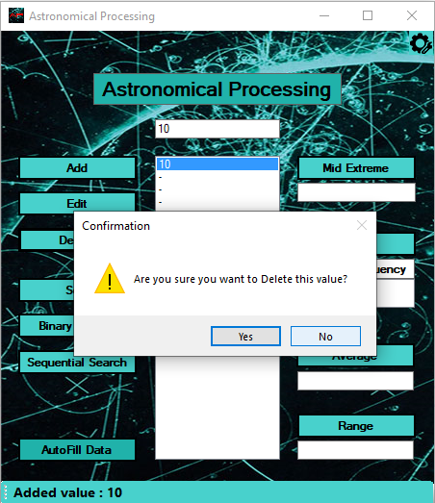 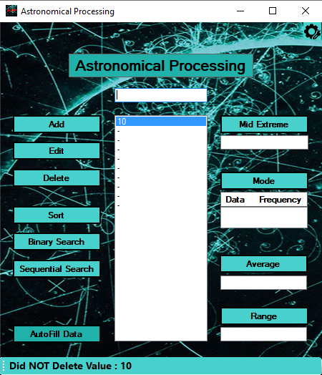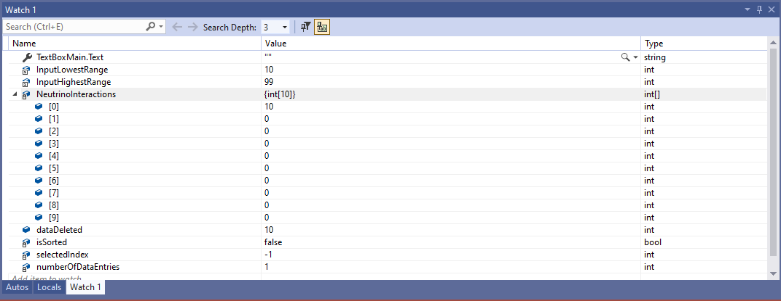

## Test Case 28

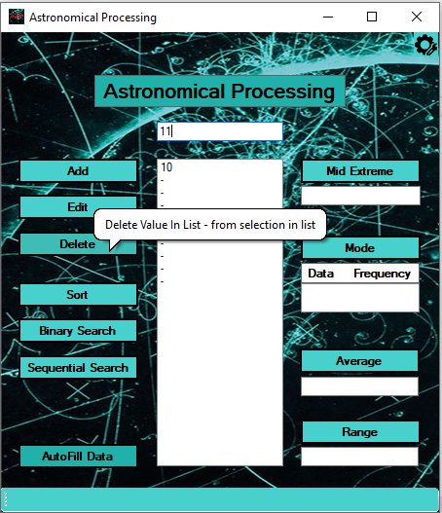 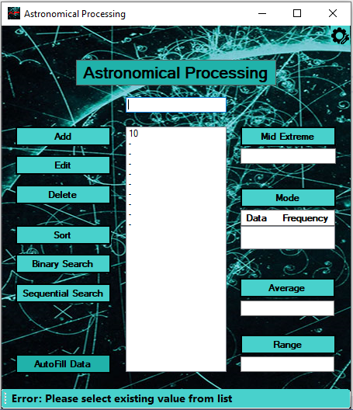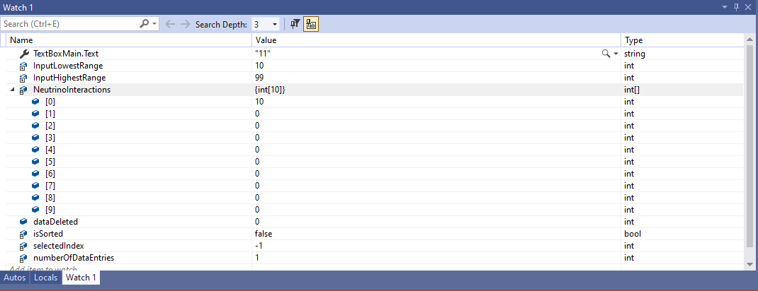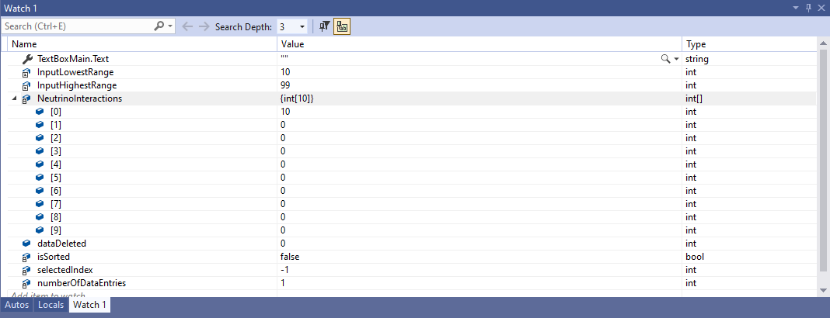

## Test Case 29

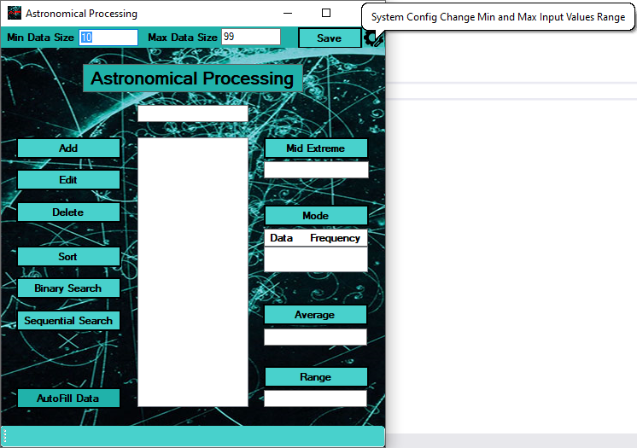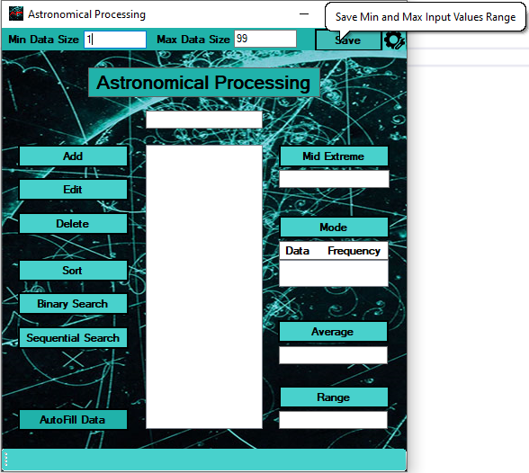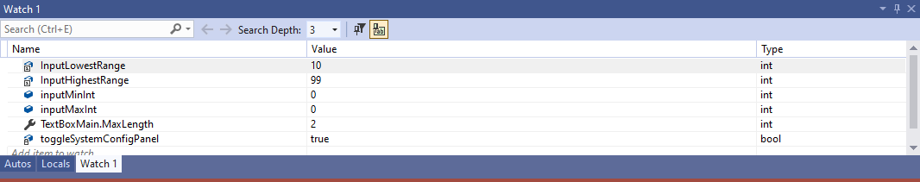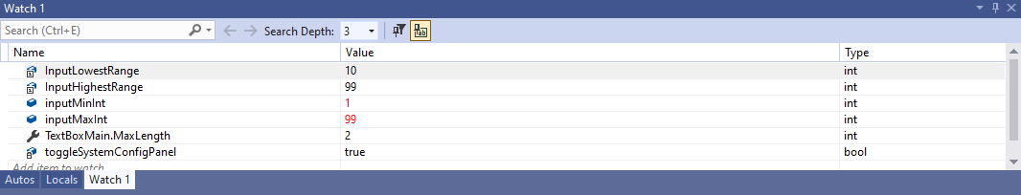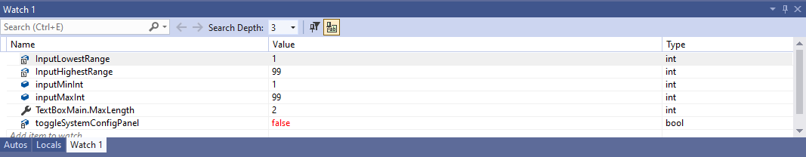

## Test Case 30

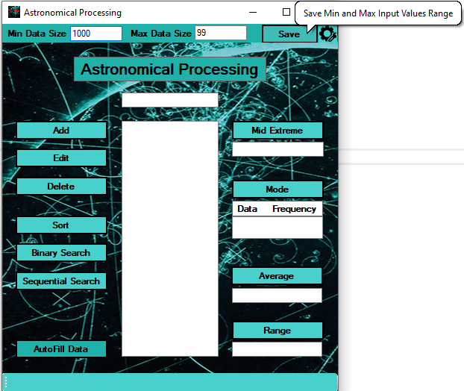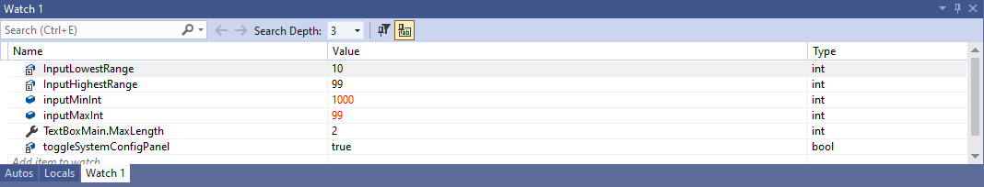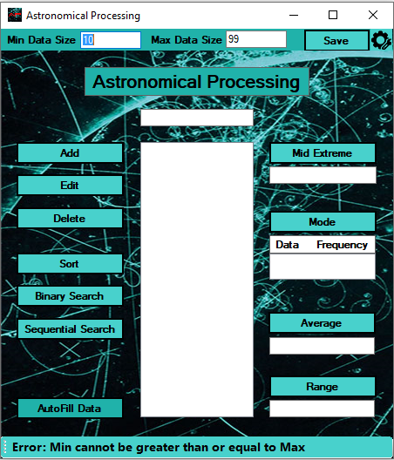

Submission Requirements

Your submission for the Handover will include:

Completed Test Report from Question Fifteen,

Completed Solution Folder for the Astronomical Processing application.

Your team will submit the working program and Test Report documentation to the appropriate Blackboard section. The following Marking Guide should be used to ensure all aspects of the final Handover assessment are covered. Consult your lecturer for further information or clarification.

|  |  |  |  |
| --- | --- | --- | --- |
| Assessment Task Two Handover  Marking Guide | | | |
| Student Name | __________________________ | | |
| Criteria | Satisfactory | | Comment |
| 1. The test data is suitable for each test case and reflects the design and development requirements. | Yes | No |  |
| 1. The test results are support with screen captures. | Yes | No |  |
| 1. The Test Report is complete. | Yes | No |  |
| 1. All documentation is properly formatted | Yes | No |  |
| 1. Participated in both sprints | Yes | No |  |
| 1. Participated in the testing/handover | Yes | No |  |
| 1. Active and supportive team members | Yes | No |  |

|  |  |  |  |  |  |
| --- | --- | --- | --- | --- | --- |
| **Assessor Name** |  | | | | |
| **Assessment Decision** |  | Satisfactory |  | Not Yet Satisfactory | |
| **Is student eligible for reassessment (Re-sit)?** | No | Yes | **Reassessment Date:** | |  |
| **Assessor Signature** |  | | **Date** | |  |

|  |  |  |  |
| --- | --- | --- | --- |
| **Feedback to student** | | | |
|  | | | |
| **Student signature** |  | **Date** |  |

**NOTE to Assessor: This is an individual submission. Please complete one checklist per student.**

End of Assessment